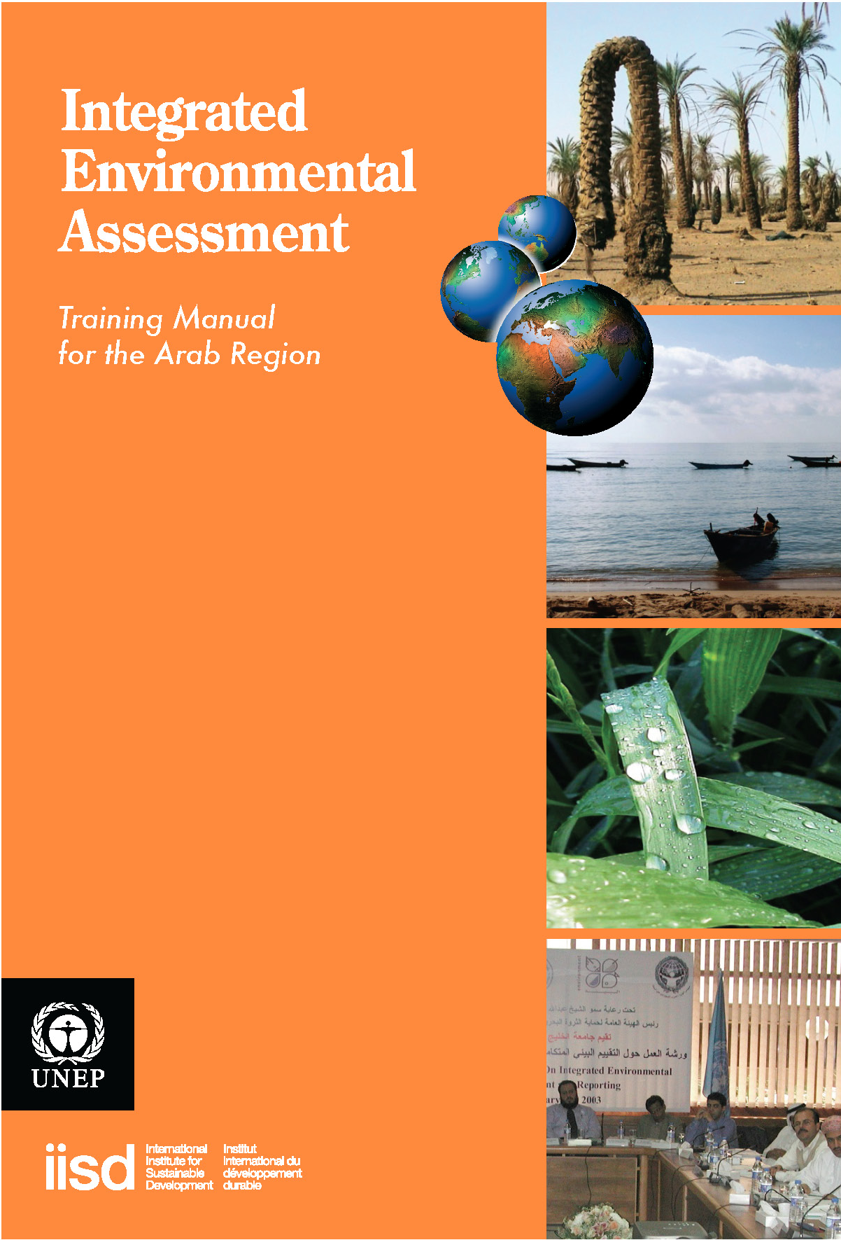
Module 3

Developing an Impact Strategy for your IEA

Authors:
Heather Creech (IISD)
Jill Jaeger (SERI)
Nicolas Lucas (WRI)
Morten Wasstol (GRID Arendal)
Jacquie Chenje (UNEP)

Localization:
Anwar Khalil (Arabian Gulf University)
Adel Abdelkader (UNEP)
Aly Amasha (CEDARE)

Editorial Support:
Mona Radwan, UNEP
Mayar Sabet, CEDARE
Tarek Abdel Monem, CEDARE
Yusuf Emad, CEDARE

Translation Team:
Yasmine Zaki
Rajia El Bialy
Table of Contents
List of Acronyms | iii
Overview | 1
Course Materials | 3
1. Introduction and learning objectives | 4
2. Understanding Impact | 4
2.1 What is an impact strategy? | 5
2.2 When do you prepare an impact strategy and who is responsible for it? | 5
2.3 Why do you need an impact strategy? | 5
3. Model for an Impact Strategy | 11
3.1 Attributes of Impact Strategies and Communications Activities | 11
3.2 Steps in building an Impact Strategy | 12
3.2.1 Step 1: Creating a “change” statement to anchor the impact strategy | 13
3.2.2 Step 2: Relationship management | 14
3.2.3 Step 3: Knowledge management | 15
3.2.4 Step 4: Opportunity management | 15
3.2.5 Step 5: Monitoring, evaluation and improvement | 15
3.3 Case Studies of Assessments | 16
3.3.1 Case study: Millennium Ecosystem Assessment (MA) | 17
3.3.2 Kingdom of Bahrain Strategy to enhance public Awareness and decision-making | 19
3.3.3 Yemen National State of Environment Report (SoE-2001) | 23
4. Pilot Training Plan | 28
4.1 Understanding the Impact Process | 28
4.2 Explanation of the Impact Strategy model | 28
4.3 Building an Impact Strategy | 28
4.3.1 Drafting the impact statement | 29
4.3.2 Identification of WHO they are trying to have an impact on | 29
4.3.3 Discussion of WHAT knowledge they need to collect and how that knowledge is collected | 29
4.3.4 Planning HOW to bring the report to the attention of targets | 29
4.3.5 Pulling the Strategy together | 30
4.3.6 Monitoring and assessing the effectiveness of the impact strateg(ies) | 30
4.3.7 Checkpoint | 30
4.3.8 Final Group Discussion | 30
References | 31

List of Acronyms

ASO Affiliated scientific organizations
GCPMREW General Commission for the Propection of Marine Resources, Environment and Wildlife-Bahrain
GEA Global Environmental Assessment Project
GEO Global Environment Outlook
IGOs Intergovernmental organizations
IISD International Institute for Sustainable Development
INC Initial National Communication
IPCC Intergovernmental Panel on Climate Change
MA Millennium Ecosystem Assessment
NGO Non-governmental organization
NSoER National State of the Environment Report
RWG Responses Working Group
SoE State of the Environment
SWG Scenarios Working Group
WMO World Meteorological Organization
WSSD World Summit on Sustainable Development

Overview
This module will focus on methods and strategies to position and deliver a national Integrated Environmental Assessment (IEA), so that it can have real impact on decision-making, environmental policy and practice at national and local levels in West Asia Region and North Africa. We want to take you through the steps that will help you determine how to engage the right people to listen to you and respond to your work. The impact process takes time; and involves a real emphasis on being clear and strategic in identifying the changes that you want to see as a result of your assessment
The process focuses on:
- Building relationship with key people;
- Finding out what they know already and what they need to know;
- Creating opportunities to get your messages across;
- Generating a dialogue, and
- Gain the attention and support of those who may have been non responsive to your assessment.
As those who have participated in previous impact strategy workshops have said, "You need to know the goals and understand the people" (IISD workshop, EMAN, 2006). A portion of the module will be presentational in nature. However, time will be spent by participants from countries of West Asia Region to discuss local social, economic and institutional factors that could affect whether and how their reports are produced and used. Small groups of participants will also be asked to practice building the components for an impact strategy for their assessment reports.

Outputs of this training module:

- The primary output should be a skeleton Impact Strategy for the participant’s next State of Environment (SoE)/ national Integrated Environmental Assessment report (IEA).
- At the end of this module, we anticipate that you will see yourself as someone capable of having a real impact on decision- making.

Notes
...................................................................................................................................................
...................................................................................................................................................
...................................................................................................................................................
...................................................................................................................................................
...................................................................................................................................................
...................................................................................................................................................
...................................................................................................................................................
...................................................................................................................................................
...................................................................................................................................................
...................................................................................................................................................
...................................................................................................................................................
...................................................................................................................................................
...................................................................................................................................................
...................................................................................................................................................
...................................................................................................................................................
...................................................................................................................................................
...................................................................................................................................................
...................................................................................................................................................
...................................................................................................................................................
...................................................................................................................................................
...................................................................................................................................................
...................................................................................................................................................
...................................................................................................................................................
...................................................................................................................................................
...................................................................................................................................................
...................................................................................................................................................
...................................................................................................................................................
...................................................................................................................................................
...................................................................................................................................................
...................................................................................................................................................
...................................................................................................................................................
...................................................................................................................................................
...................................................................................................................................................
...................................................................................................................................................
...................................................................................................................................................
Course Materials

1. Introduction and Learning Objectives

This module will focus on methods and strategies to position and deliver a national Integrated Environmental Assessment (IEA) so that it can have real impact on environmental policy and practice at national and local levels.
At the end of this module, you should have enhanced your ability to:
- Articulate reasons for doing an Integrated Environmental Assessment, including but also beyond mandated requirements.
- Understand the political context of what you are doing and how are changes made in policy and practice in your country.
- Move beyond awareness of the importance of impact and communications, to develop real strategies and communication tactics to achieve impact. Explore how far you can go with achieving impact through your assessment.
- Increase recognition of who you want to reach beyond your immediate departments, and how that will affect how you undertake your work and what you will do with your outputs.
- Recognize that impact requires more than the production of a report at the end of the assessment; that strategic positioning of your work and planned communications interventions are essential components of your work that should be undertaken in parallel with all stages of the assessment.

Changes desired in participants:

- They consider themselves as effective contributors who are capable of having an impact on decision making;
- They see communications as an essential component of their reports that should be undertaken in parallel with all stages of the assessment.

Reading and exercises to be done by the participants prior to the workshop:

- Case studies (National WSSD Reports, and SoEs).
- Two to three relevant articles on impact, influence, communications processes
- Research the political context for their assessment: why has it been mandated? Who supports it in their government? Who doesn’t?
- Count the number of stories in their newspaper over a week related to environment, health, and development.
- Find sources of public opinion polling data in their country.
- Find relevant data and resources on stakeholders and NGOs role and involvement in assessment processes in their countries.

2. Understanding Impact
In this section you will learn:
- Why it is important to have an impact strategy,
- How to understand the external environment (context) for an assessment,
- How to recognize an issue cycle [using media, polling data]

2.1 What is an impact strategy?
An impact strategy consists of the steps you take to ensure that the work you do will leverage real progress on key issues or concerns. It is proactive in nature, and adaptive in a public policy environment where priorities of governments and citizens can shift and change.

2.2 When do you prepare an impact strategy and who is responsible for it?

An impact strategy should be prepared by the management team once you have initiated the process for an Integrated Environmental Assessment. It is part of the “institutional setup” for an assessment process of a GEO-style IEA (See Module 2). It should be initiated at the Scoping and Design” stage, implemented, regularly monitored, assessed and improved. The management team, for the IEA process should be responsible for:

- Developing the impact strategy, or ensuring that an impact strategy is developed;
- Implementing the impact strategy; and
- Monitoring performance on the strategy to ensure that it is achieving the anticipated results and modifying or adjusting it, if necessary.

2.3 Why do you need an impact strategy?
- State of the Environment or Sustainable Development Reports are now mandated by national statutes and regulations in almost all the countries of West Asia Region. In some cases, strong policy context may lead a government to undertake or participate in an assessment as a voluntary initiative. In others, the assessment/reporting programme may be part of a larger performance monitoring and evaluation programme, across all government departments. While such requirements may initiate the IEA process, you should think about the potential uses of the assessment. What are the expected impacts on national and local polices and planning. Who are paying attention to the findings of your assessment?
- SOE/ environmental assessments are not detailed scientific assessments. However, they may focus more attention being paid to problem areas, and they may recommend a more detailed scientific assessment of root causes and downstream effects. The findings of the assessments can also lead to political pressure, educate wide ranges of audiences on key issues and as a result it may initiate more detailed investigations that are directly linked to specific issues and decisions.
- It is often understood that good information will lead to good decisions. While good information is necessary, it does not follow that decision- makers will act on it. Decision-makers are often quite well informed, but their priorities may be different from your. Take proactive steps to ensure that your assessment doesn’t sit on a bookshelf once it is done, but that it provides good input to decision-making. Your assessment will lead to recommendations for actions that may require changes in policy and practice by the government You should plan from the outset how the findings from your assessment might be used, and how the priorities you identify, become the priorities of your government and your country.
- An impact strategy begins with articulating what you would like to see changed as a result of your work. This provides you with purpose beyond simply following through on the mandated requirement for the assessment. For those conducting an IEA for the first time, it may not be possible to articulate a specific policy-related change that might be necessary as there is no prior assessment which identified priority issues. For them seeking better linkages between the findings of the report and formal decision-making process in government may be their main objective. Those conducting the assessment for the second time or more might be able to think more specifically about issues and necessary policy changes identified from the first process.

Regardless of whether this is your first assessment or not, it is important to have a good understanding of several factors:

- Why the assessment has been mandated? What is the political and bureaucratic context in which it is taking place? A legislative mandate as articulated in Module 2 is powerful: having such a mandate makes it less likely other influences will prevent you from initiating and completing your report. However, once the report is done there are often no obligations to address its findings, so it is equally important to learn who supports the practice of assessment, and where might be opposition to the process. Those people may be key bureaucrats in your own department, or in other important government or non-government agencies. Those who are supportive are prime candidates to become champions of the findings. They should be briefed on the process from the beginning, informed and even engaged in the process and be key recipients of presentations and policy briefs on the findings. Those who have concerns about the whole concept and practice of assessment may become detractors- either critical of the report, or focusing attention away from the report and on to other government matters. Consider how you might best build bridges with them and there might be common ground.

- If SOE reports or assessments have been prepared in the past in your country, what happened to them? What priorities for action were recommended? Were they acted upon? Why (or why not)? Barriers to use of previous assessments may continue to be barriers; but by identifying them ahead of time, ways to overcome them may be identified.
- Who is involved in the assessment: In advance of starting the IEA process, you may identify some of the people who will have a role in the assessment. Certain participants can add legitimacy to an assessment. In some cases, the participation of external experts and agencies, including UNEP, can be helpful to ensure that the process is respected.
- What is taking place within your country that might provide a “window of opportunity” for you to gain public attention to your findings? For example, if there is a debate going on about health impacts of air pollution, you should think about how your findings can contribute to that debate. You might personally be interested in an issue such as water pollution, but by looking for the connection to the issue on the top of today's public and political agenda, you could promote your assessment in the context of the “issue cycle" which may be the air pollution agenda.

There are many ways to get a sense of the external political and public environment in which your assessment is taking place:

- Review not only the relevant statutes and regulations that govern the assessment, but also review the debates in parliament and parliamentary committee minutes at the time. Find the background white/green papers, or other relevant policy documents.
- Investigate with current/former bureaucrats their recollection of the process involved in securing the mandate to do the assessment.
- Monitor political and social coverage in the national media – what does the media think is worth reporting?
- Attend meetings of NGOs and community based organizations within and outside of the environment sector. Find out what their priorities are. Hold focus groups to identify user needs and interests.
Be aware that if your assessment serves only to produce a report to comply with a legal or policy instruction, or only relevant to the scientific community, (just on agenda) then the impact – the ability to have your findings used to effect change – will be severely limited.

DISCUSSION QUESTIONS

Form groups of 3-4 and discuss the following questions. Be prepared to share your answers in plenary.

- What was the context for previous assessments that have been conducted in the past? Are you operating under a legal or policy mandate? Is your assessments part of a larger programme for government accountability?
….……………………………………………………………………………………
……………………………………………………………………………………….
- Why your assessments were mandated, directed or commissioned? Were your assessments a high priority for your superiors? What other things concern them?
….……………………………………………………………………………………
……………………………………………………………………………………….
……………………………………………………………………………………….
- How did/will higher-level decision-makers use your findings?
….……………………………………………………………………………………
……………………………………………………………………………………….

Understanding Issue Attention Cycles
In preparing a successful impact strategy, it is important to be aware of levels of public, political and bureaucratic attention to current issues, and to the issues being explored in your assessment. Levels of attention will influence the choice of actors whom you need to engage in your work or how to engage them. Understanding what is on the public radar screen will also help identify where your assessment might be useful in bringing new knowledge and recommendations for action. It has been found that for environmental risks there is generally a pattern that resembles a “Classic” issue attention pattern. In West Asia Region as well as in other regions, social attention to global environmental risks has tended to lag for years behind scientific and technical developments. In certain instances these rise relatively rapidly and continue high for a short period, then drops off again (Social Learning Group 2001).
The research of the Social Learning Group suggests three phases of issue development (Figure 1). During the first phase, before the issue first achieves widespread public attention, the principal functional change is the gradual build-up of scientific and analytic capacity through research, monitoring and assessment activities. Over a long period characterized by relatively low public attention, society’s capacity to address new issues gradually accumulates within a relatively fixed group of institutions, largely determined by historical circumstances and the way the issue is perceived. It is unlikely that new institutions will become involved to a major extent with the issue during this period of low attention.
The subsequent period of rapid rise in public attention marks a second phase in issue development. During periods of rapid rise in public and political attention to a new issue, there will be a renegotiation of leadership within already engaged institutions, and a need for new institutions will emerge. At this stage of issue evolution, it is important to recognize the need for coalitions of actors to push the issue forward. These coalitions provide the basis for a shared understanding of the problem and its possible solutions. Effective management of emerging issues will therefore encourage this coalition building rather than encouraging generally increased participation by individuals, or isolated groups of actors.
A third phase of interactions among management functions is associated with the period following the peak in public attention and continuing through the subsequent decline in attention. During this period, the linkages between the knowledge-intensive and action-intensive management functions increase in frequency and run in both directions: knowledge influences action and vice versa.
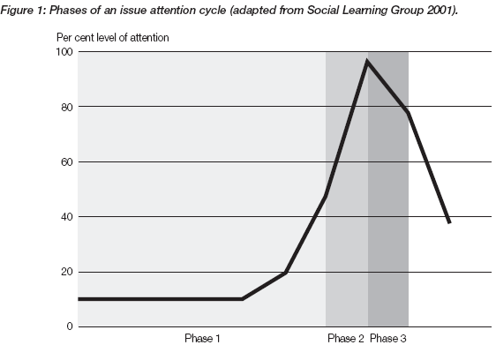

EXERCISE 1:
In preparing for this assignment, you were asked to:
Review the number of stories in your country's newspapers related to environment, health and development in the week prior to your training; and
- Find sources of public opinion polling data in your country and review them for the current year.
Based on your “homework:”
- What issues are of most concern to citizens in your country right now?
- How is your political leadership responding and;
- How might you align findings from your assessment with these concerns?

The climate change issue attention cycle
The case of attention to climatic change is illustrated in Figure 2. This graph charts levels of public interest in climate change as indicated by coverage of the issue in the elite newspapers of several countries. While the graph only shows the media coverage, additional research carried out by the Social Learning Group suggests that the levels of attention accorded to climate change in the elite media correlated strongly with levels of attention shown to it at the same period in time by other actors such as parliaments, industry groups and the scientific community. The media data can thus be taken as a rough reflection of overall changes in levels of attention to global environmental risks among actors.
Of particular interest in this graph is the one- or two-year period of rapidly increasing attention, then a year or two with the issue in high profile, and finally a slow decline of public attention back to lower levels. Over sufficiently long periods, recurrent cycles of public attention are possible (possibly indicating that lower attention levels have more to do with the emergence of new priorities. or media and public fatigue, rather than a resolution to the problem).
Much as in the cases of acid rain and stratospheric ozone depletion, climate change was an expert issue long before it became a public one. There was relatively little attention to climate change in the press of any arena prior to 1988, despite decades of sustained scientific work. In this case, “issue linkage” appears to have been a critical factor in getting climate change onto the agenda of the public and policy-makers. The rise of stratospheric ozone depletion to the political agenda forced a certain amount of political attention in at least some national and international arenas to the issue of global climate change.
Also important was the role of political leadership. During the last two decades high-ranking politicians in many of the politically powerful arenas started to speak about the need to take action regarding a global warming threat. Their attention was secured by proactive, strategic and personal efforts on the part of scientists and concerned citizens working in NGOs. This put political momentum behind scientific developments in several arenas.
Climate change remained on the public agenda even when media attention to stratospheric ozone depletion began to decline. In the period after the data collected for Figure 2, evidence suggests that attention dropped sharply in most arenas towards the mid-1990s before rising again in the run-up to the Kyoto Conference of 1997 (Social Learning Group,2001). This might signal that once an issue receives a high level of both public interest and political support, it will remain on the bureaucratic agenda even though public interest may shift to other concerns.
- For the impact strategy, it is important to be aware of where the issue that is to be assessed lies with respect to the attention cycle. If the issue is in the first phase, in which most attention to the issue is in the scientific and technical realm, the impact strategy should consider that the audience most likely to be interested in the IEA will be in this area. It will take more concerted effort to gain the attention of the general public, private and political interests.
- During the second phase in which there is a rapid rise of public and political attention to the issue, there is a “window of opportunity” in which the impact strategy can consider the possibilities of reframing the issue and attracting new actors to become involved in dealing with the issue.
- If the issue is in the third phase, where the issue is on both the scientific and political agendas and there is considerable interaction between these communities, the impact strategy will be able to address the broader communities of concerned actors, when scientific analysis, public interest and political agendas are closely linked. It is at this stage that an impact strategy may have its most obvious and immediate results. Keep in mind though, that an impact strategy developed at this stage will be ineffective. The strategy must be developed early; it will just have its greatest impact at this stage.
There is a certain inevitability that issues will recede from the attention of the general public. An impact strategy may help to:
-mitigate the falling off of public attention by focusing on more direct engagement of target decision-makers; and
- shorten the issue attention cycle by moving a relevant issue back into the public eye more frequently.
There will always be unexpected catastrophic events that can play a major role in tectonic shifts in public policy. In these circumstances, public interest and policy response may peak simultaneously, with pressure placed on knowledge seeking efforts for rapid response. One has only to consider, for example, the effect of the 2004 Tsunami in Asia,the 2010 Tsunami in Japan and cyclone Gonu in Sultanate of Oman in 2007 on policies to implement early warning systems. These events can have two outcomes for your own impact strategy:
-You can seize the opportunity to relate your assessment findings with the catastrophic event. For example, in 1997, one could have tied SoE report findings on land management to the massive land-clearing fires and resulting haze blankets across Asia that led to $US1.4 billion in short-term health costs and fire damage (IISD 2002), and you could also relate your analyses to the environmental damages caused by the cyclone Gonu to the coastal recourses in the Sultanate of Oman. Or
-Your work will be moved off the political and bureaucratic radar screen for the immediate future. You will need to complete your mandated requirements for the assessment, but continue to foster the relationships built through the process, and be ready for the time to advance the findings.

Although all the countries of West Asia and North Africa have signed and ratified the UNFCCC, only half of them have completed their first Initial National Communication on Climate Change. The issues related to climate change are not regularly reported by the local media due to lack of data and support by decision-makers. Recently these issues became not only the concern of scientific institutions, but also moved into the concern of politicians and decision-makers. In this case "issue linkage" appears to have been a critical factor in getting climate change onto the agenda of the public and policy makers.
The evidence of high level of political attention to the issues of global climate change in OPEC nations and particularly in the Arab States of the Gulf Cooperation Council was highlighted when the leaders of these nations, in their Third Summit meeting in Riyadh decided to allocate financial resources to conduct research and to take appropriate measures and actions regarding global warming impacts. Details of the declaration were:

Box. 1: Research on climate change

OPEC nations pledge financial resources:
The Third OPEC Summit, in Riyadh, gave conspicuous attention to the issue of the environment and what practically needs be done to combat climate change. Much discussion revolved around renewable energy and the impacts of energy policies on developing countries. OPEC nations took a step further to commit financing to studies expected to go some way toward reversing current inclement trends in global warming. At the Summit, the Kingdom of Saudi Arabia took the lead in announcing a US$300 million endowment toward such research. Saudi Arabia was followed by three other Gulf States: Kuwait; Qatar and the United Arab Emirates, each of which pledged US$150 million, bringing the total commitment to US$750 million. Other OPEC nations are likely to follow. According to various sources, the funds would support cleaner and more efficient petroleum technologies to help protect the local, regional and global environment. The funding will also help enhance the development of technologies such as Carbon Capture and Storage (CCS). Furthermore, the endowment is expected to help promote the transfer of environmentally-friendly technologies from advanced countries to OPEC- and other developing countries, (OFID NL 2007, .XIII-no.3).

Figure 2: Country comparison of newspaper attention to climate change
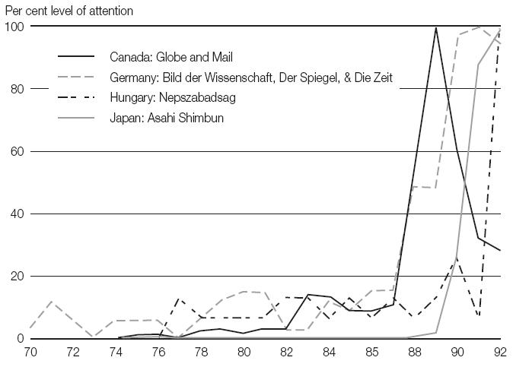
Source: Social Learning Group 2001
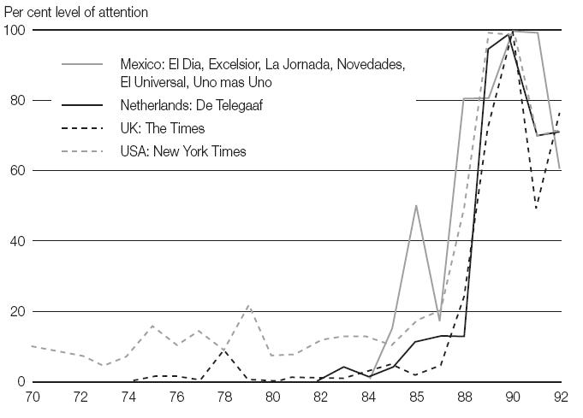
Source: Social Learning Group 2001

3. Model for an Impact Strategy
In this section, you will learn:
- The difference between an impact strategy and a communications activities
- What are the basic components of an Impact Strategy
- How global organizations and countries of the region have developed strategies so that their assessments might have impact on decision making

3.1 Attributes of Impact Strategies and a Communications Activities
An impact strategy incorporates communications activities combined with a good understanding of government relations and the political context as practiced by various advocacy groups. With communications strategies, it is necessary to identify key recipients of the assessment, prepare key messages and products that will help them grasp the essentials of the research, and identify appropriate channels to deliver those messages and products, including the media, participation in events (e.g., conferences, workshops), electronic delivery via e-mail and web. In Module 7, you will learn more about the full range of tools and tactics available for production and release of the reports and its supplementary products.

An Impact Strategy builds on Communications activities in several respects:
 | Impact Strategy | Communications Activities
Purpose | Focused on effecting change, and on the potential of your role as a change agent | Focused on the effective and efficient communications of the findings and recommendations
Audience | Small group of key actors and those who have access to them | Broader audiences
Timing | Developed at the beginning of the assessment process, and monitored and adjusted throughout the process | Part of the impact strategy; usually implemented towards the end of the strategy when findings and recommendations are known.
Source: Creech, et al. (2006)
- Purpose
An impact strategy is focused explicitly and deliberately on change, and on the potential of your role as a change agent. An impact strategy starts with an articulation of what you would like the impact of your assessment to be. What would you like to see done differently as a direct result of your assessment? Some of the power to effect change based on the findings may indeed rest with you, depending on your role within your bureaucracy. Usually you should engage those who will bring about policy reform, or leaders in the public and private sectors who may have a role to play in changing practice. An impact strategy identifies these key actors and plans for ways to build their receptivity to your findings.
The Communications activities tend to focus primarily on the effective and efficient delivery of the findings and recommendations. The communications strategy also often has an important corporate function: promotion of the department of government that has been responsible for developing the report and demonstrating accountability through compliance with the mandate for the assessment.

- Audience
In developing your impact strategy, you may determine that there are a small group of key actors who are in a position whom you want to influence with your work, and that your efforts in ensuring take-up of your findings and recommendations should be focused primarily on them. Directly reaching these influential actors, however, may be difficult. Instead, the impact strategy may target those who are able to influence them or try to reach them through other channels indirectly. You will need to cultivate and shape the opinion of others who have influence with these key actors. Your ultimate objective should be to reach those people whom you definitely want to act on the IEAs results.
Communications activities will always include broader audiences: those who can benefit from the information contained in the report and become actors in their own way.

- Timing:
An impact strategy should be developed from the very beginning of the assessment process, monitored, evaluated and adjusted throughout the process. The communications strategy is an important component of the impact strategy, and is usually implemented towards the end of an assessment, once the findings and recommendations become clear.

EXERCISE: 2
- Share a story from your own experience, about how assessments have been communicated in the past, to decision makers, to the public
- Discuss in particular the roles of different players: who was responsible for delivering the final report, what were their tasks, who were their target audiences; who handled the release to the general public, and what vehicles or channels did they use to get the information out?
- Were you satisfied with the response to the assessment?

3.2 Steps in building an Impact Strategy
There are five main steps to creating an impact strategy, based on IISD’s model (Figure3)

- Creating the change statement What should the impact of your assessment to be.
- Relationship management. Identifying the key actors that you are seeking to influence, and building connections to them.
- Knowledge management. Gathering and analyzing the knowledge for the assessment.
- Opportunity management How to move the knowledge into the hands of those you want to influence.
- Monitoring and improvement Determining whether your impact strategy is working and adjust it as necessary.
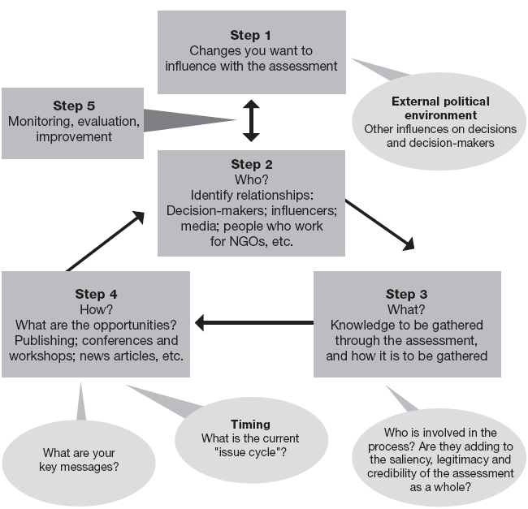

Figure 3: Model for an Impact Strategy (Source: IISD, 2004)

Note the iterative nature of the Strategy. These steps are elaborated below:
Who is involved in the process itself: are they adding legitimacy, credibility and saliency to the knowledge base? Note that these three criteria were identified as key to the effectiveness of assessments. Legitimacy refers to ensuring that the assessment is carried out in a fair and politically acceptable way, taking the views and values of the respective audiences into account; saliency mean that the assessment addresses the information needs of its users; and, credibility means the technical and scientific reliability of the information (Jäger and Farrell)

3.2.1 Step 1: Creating a “change” statement to anchor the impact strategy
An impact strategy is anchored by its “change statement.” This is an articulation of what the impact of your assessment should be. What should be changed or done differently as a direct result of the assessment? This first step will be the most challenging: to articulate clearly what the leaders and participants of the assessment would like to see happen as a result of your IEA. Although your government may mandate assessments, it is important to look beyond the simple requirement to undertake the assessment, and consider how the assessment might lead to changes or improvements in sustainable development policy and planning.
For those conducting an IEA for the first time, it may be difficult at this point to state what the issues are that need to be influenced. The change statement may be fairly broad, focused primarily on getting people in positions of authority to actively use your report. For example:
Key departmental decision-makers will use the information gathered during the assessment to develop policy priorities, departmental strategic plans and budgets. Or:
State, as well as national, level planners will review the findings of the assessment, and prepare internal policy briefs on how they will address the recommendations of the assessment.
Remember that an important part of the IEA process is a scan of issue and policy priorities. In the context of any given priority issue to be reported, major policy mechanisms that could or should be influenced can also be identified. An impact strategy is a dynamic process. The change statement may start off fairly broad or general, but as more data become available and analysis is carried out, the change statement can be revisited and refined. During this training session, when you learn more in Modules 4 and 5 about data and analysis, you may wish to reconsider how you have framed the change statements you will prepare in the next section of this module. Based on the findings of previous assessments, or on the new data being analysed, you may wish to focus on one key priority that you want your findings to inform and address, e.g.:
The government institutes a national watershed management plan that takes into consideration the responsibilities and capacities of villagers to protect and rehabilitate their water sources.
You can still reach out to broader audiences to inform and engage them in the report findings. Impact in this context may be an aggregate of actions that individuals may take in response to the report. But there may be little that they can do on a personal level. The impact strategy will help you work towards leveraging real policy change on a key issue.
EXERCISE 3
- How you would like to see your assessment used?
- Describe a situation (a government policy or practice) that could be improved as a result of your assessment.

3.2.2 Step 2: Relationship management
Too often, people move immediately to the information gathering stages of the assessment, without due consideration of Step 2. Careful thought should be given to who will be in a position to take the findings of the assessment and use them effectively. Information by itself doesn’t leverage change, but relationships do, and this involves people communicating ideas, analysis and data to other people. This step involves identifying the individuals and groups you most want to reach. Consider how these decision-makers acquire information, who do they trust, what information source do they trust and how do they make decisions? How can you get to those people? If you cannot reach them directly, who are the people they do listen to, and can you reach them instead?
This step is designed to identify those who are in positions to make the decision or effect the changes including those who can influence the decision-makers directly. These include intermediaries, the people who lean in to whisper advice into the ears of the decision-makers, those in civil society who can bring pressure to bear on decision-makers, those who can support, reinforce and strengthen your recommendations, in particular the academic community and other research institutes, and those in the media through whom we reach the public, who can also influence decision-makers. Central to determining who to reach is the concept of relationship management: maintaining the connections and influence over time.

3.2.3 Step 3: Knowledge management
Once you have articulated who will help with achieving the decision you seek, you need to analyse both what they need to know, and what you need to know that will help them take or influence the decision. This is the knowledge management process of the assessment. The remainder of the Training Manual will provide you with the tools you need to gather, analyse and process your information.
You will need to consider how to build trust in your final product, including the data, the analysis and the recommendations. As outlined in Module 2, participation by your key decision-makers in the actual process of the assessment ensures saliency and relevancy to your finding (GEA 2005). In other words, it helps to ensure that the findings are relevant to their needs and will be more likely to be used. This could include not only leading scientists who ensure the assessment reflects the latest scientific results, but also others such as indigenous people whose traditional ecological knowledge can broaden the assessment’s perspective or corporations that may have access to more in-depth and privileged information. Generally, the constructive collaboration of a wider set of actors may increase not only the credibility of the IEA but its legitimacy in the eyes of a broader set of social stakeholders.

3.2.4 Step 4: Opportunity management
Step 4 involves moving that knowledge into the hands of those you want to influence. There are many tools available to do this: the products to be released, the conferences and workshops to hold, and the amplifiers, including electronic mailing lists and websites, which get replicated throughout much wider audiences than may have been targeted.
At the heart of the tactics and strategies that are developed is the creative management of opportunities: both taking advantage of key windows to move the assessment findings into the hands of others, and creating opportunity directly.
An important part of this process is the development of “key messages,” a series of short, simple, plain language statements that capture the essence of the work. There is a real skill in drafting statements that capture the essence of what you want to say, and expressing it in a way that is relevant to those you wish to influence and inform. This can be done with end users and tested in focus groups. The IPCC case study talks about one of the “key messages” from its work:
The world is likely to see “a rate of increase of global mean temperature during the next century...that is greater than that seen over the past 10,000 years.”
This straightforward message was by most accounts, very influential in catalyzing the decision making process, which eventually led to the signing of the UN Framework Convention on Climate Change in 1992 (Agrawala 1997).
Also, keep in mind what you have learned about “issue cycles,” recognizing that timing is important as you seek to position your findings in light of other competing or comparable public and political interests.
The development of scenarios based on the findings presents another type of opportunity to engage key target decision-makers. Scenarios help decision-makers deal with uncertainties, and provide options for action. The value of scenarios in helping decision-makers to buy into, and act on, your findings is discussed further in Module 6.

3.2.5 Step 5: Monitoring, evaluation and improvement
We know that in most work involving information processes and products, causality is difficult to demonstrate. But it is possible to look at incremental changes in attitudes, actions, and behaviours that are a direct outcome of one’s work (Earle et al. 2001). Monitoring, evaluation and learning mechanisms should be in place to identify and map these incremental changes that will lead towards the decisions or changes sought, and to adjust the strategy if necessary.
Naturally, you are going to want to know whether your strategy is working. But, sometimes the signals that you are having real influence seem small and insignificant. These quiet signals will be the incremental changes in attitudes, actions and behaviours that are a direct outcome of your work. Monitoring and assessment mechanisms must be in place to identify and map these incremental changes that will lead towards the decisions or changes you are seeking. This can be a time intensive process, so it is a good idea to identify some key indicators, and set up simple ways to monitor your strategy against those indicators.
Important behaviour changes of your “target actors” (those you are seeking to influence) could be reflected in a progression from passively receiving information from the assessment, all the way through to acting on recommendations and demanding more work. The following would be a good checklist:
- Receiving information
– IEA process leaders sending information to target actors.
– IEA process leaders using media to communicate to target actors.
– IEA process leaders requesting, and securing, meetings with target actors.
- Seeking and processing information
– Targets seeking information from others to “triangulate” or verify information they are receiving through the IEA process.
– Media reporting messages from target actors that are consistent with IEA process messages.
- Acting
– Issuing of new policy briefs, white papers, frameworks, regulations, other responses.
- Demanding
– More work from IEA process leaders (e.g., follow-up investigations, more in depth assessments).
These and other indicators are discussed in more detail in Module 8 on monitoring and evaluation. There, you will see how monitoring the impact strategy will fit into the overall monitoring process.

EXERCISE 4
- What indicates that the assessment findings and recommendations are influencing your key actors?
- What are some ways to keep track of your performance on the strategy?

3.3 Case Studies of Assessments
Despite the lack of concrete examples, it is possible to look at particular assessment processes that have had some impact success, which can provide the participants from the Region pointers for the development of an impact strategy. The Millennium Ecosystem Assessment Reports provides such an example. In West Asia countries, most of the environmental institutions are legally mandated to monitor environmental problems and to produce SoE and assessment reports, (Command and Control Policies). Although the Region is short of needed environmental databases, trained and experienced personnel, nevertheless, some countries have succeeded in producing SoE reports and national environmental strategies and action plans. We will present in this section some of these assessment reports as case studies, which include:

- The Millennium Ecosystem Assessment, (MA). A case for the global scientific assessment, it has deployed strategies to ensure that their findings have impacts on international policy and national decision-making.
- Kingdom of Bahrain strategy to enhance public awareness, decision-making and capacity building to mitigate and adapt to climate change.
- Yemen, State of Environment Report, (2001).

3.3.1-Case study: Millennium Ecosystem Assessment (MA)
The Millennium Ecosystem Assessment (MA) represents a considerably detailed and rigorous assessment than what is usually found in the national level SoE reports. It has deployed and instituted “engagement and outreach” strategies from the beginning to ensure that their findings have impacts on international policy and decision- making. The MA directors understood the need to ensure that key actors would be engaged and informed, broader audiences would be reached, and that this process would have to be carried on as an integral part of the whole scientific assessment – not as a parallel activity, or as an activity initiated towards the end of the scientific work. It is presented here as an excellent example of “best practices”:
Step 1: Impact statement: What did the MA want to see as the outcome of its work?
The Millennium Ecosystem Assessment was carried out to assess the consequences of ecosystem change for human well-being and to establish the scientific basis for actions needed to enhance the conservation and sustainable use of ecosystems and their contributions to human well-being.

Step 2: WHO are the key actors, and how to build relationships with them
At the beginning of the scientific work, the proponents of the MA (a coalition of organizations and individuals), proceeded to:
- Confirm the need for the assessment by consulting with some of the key user audiences, in particular the three main international conventions that directly deal with ecosystems (Convention on Biological Diversity, Convention to Combat Desertification and Ramsar Convention on Wetlands);
- Position the assessment within the formal decision making processes of these conventions and obtain formal expression from the UN on the need to conduct the assessment;
- Identify a broader range of users, collaborators and institutions in sub-global and regional centers to consult, produce assessments, review, monitor and evaluate reports.

Step 3: WHAT knowledge is to be gathered
In addition to consultations with their key actors, the MA conducted an assessment of the information needs of a broader range of users. This user needs assessment became the basis on which the outline of the MA reports were designed by the scientific panel and remained a check point of reference throughout the process.

Step 4: HOW to reach key actors and broader audiences
The strategy was built around two areas of action:
. Engagement
- Provide to the target users adequate access to the process of generation of data and information.
- Provide adequate access for a broad range of users to the benefits of the assessment (products, networks and capacities).
- This in turn would result in input from users into the processes of the assessment, enhancing its legitimacy and capacity.

Several channels to enable the engagement strategy were used. For example:

- The user needs assessment was used to obtain information from users and strengthen the relevance of the assessment;
- The MA constantly made ad hoc briefings to various audiences, to address large numbers of users and present them with information about the assessment;
- Open calls were issued to the public but especially to governments and institutions to nominate scientists to participate in the assessment as authors or reviewers and to submit proposals to undertake sub-global assessments affiliated with the MA;
- A website and newsletter were established and a data sharing system developed.
- The internal, formal procedures of some of the target users were utilized to feed the MA and subject it to discussion. This was particularly the case with those international conventions targeted, bringing the MA to the attention of their technical and political decision-making bodies.
- Multi-stakeholder meetings were organized in various countries to present the MA and invite discussion on its relevance in each national context.
- A procedure to invite academies of sciences and scientific organizations was established whereby these entities supported the MA in the identification of scientists and the dissemination of information.
- The process of sub-global assessments was in itself another mechanism to connect the MA to local, national and regional processes.

. Communication (outreach)

- To raise the level of awareness about the MA and, to elaborate its basic concepts and improve the understanding of what it was and how to use it.
- Convey the key messages resulting from the findings of the MA reports to targeted audiences and the general public at large.
- Integrate assessments at the sub-global and regional levels; and
- Training at the affiliated institutions to undertake sub-global and regional assessments were conducted.
The engagement and outreach team of the MA saw its communication activities as an instrument not just to reach out and convey an image of the MA but also as a mechanism to enhance the ownership over the MA and improve the ability of third parties to understand and make better use of it. This was highly beneficial when the main media outreach effort came through, generating materials to support outreach by third parties. These materials were shared through the intranet, but also through an ‘Outreach Kit’ distributed on CD-ROM. This Kit contained a collection of elements developed by the MA, including:
  - Guidance on how to explain the MA to the uninitiated;
  - Guidance on how to develop a communications strategy
  - Graphic elements (posters, maps, logos, photographs, videos);
  - PowerPoint Presentations

Step 5: Monitoring, evaluation and improvement
From the beginning, the MA engagement and outreach team was concerned with the question of success. Monitoring and evaluation were essential components to measure and establish whether their efforts were successful in supporting the goals of the assessment. Some of the items that were discussed:

- ‘Government buy-in’? Expressed how? Through resolutions from international bureaucracies? Is this an indicator of the effective use of the information or a tactic to protect the process? Government involvement, however, was very effective in attracting leading scientists
- An international arrangement to deal with the problem? Was the MA insert in a clear political context in which the information would catalyze such action?
- A proliferation of sub-global assessments? Would the dissemination of the practice of integrated assessments around the world be an indicator of real success?
- Media attention? Besides being short-term, one has to be careful what the results of this attention are.

In an effort to engage and communicate effectively, the MA developed some metaphors to elaborate its basic concepts and major findings. The most significant and relevant was that of “nature as capital” and “ecosystem services”. These were clearly effective, though some of them were controversial.
At the end the project team concluded that the success for the assessment can be measured by demand for information and for expertise from a range of places and interests.

3.3.2 Kingdom of Bahrain Strategy to enhance public Awareness and decision-making:
Introduction
Kingdom of Bahrain signed the United Nations Framework Convention on Climate Change (UNFCCC) in 1992, ratified it on 28th December 1994, prepared and submitted its Initial National Communication (BINC), in 2005. In the context of undertaking the national communication, there was a need to build and strengthen the national capacity to integrate climate change concerns into medium and long-term planning, and to develop programmes related to sustainable development, research, education, public awareness and training, (GCPMREW,2005). A key output of the BINC was the formulation of a draft national strategy to raise public awareness, (Khalil, 2004;Zubari et al. 2004). The goal of the strategy was to enhance the public consciousness and awareness with respect to the environment and encourage behavioral changes conducive to climate change impacts reduction measures, adaptations, environmental management and protection.
Such a strategy was essential for moving toward a better understanding of both the potential impacts on Bahrain from a changed climate, as well as what its youth, civil society groups and government agencies can do in mobilizing mitigation and adaptation activities. While it resembles a "communications strategy" the components of Bahrain awareness strategy corresponds to the steps of an impact strategy:

Step 1: Impact statement: what did the strategy want to see changed as a result of the assessment?
Bahrain's awareness strategy stated from the beginning that, "a key step towards meeting the challenges posed by a changing climate is to initiate a national dialogue to raise awareness among key policymakers, civil society organizations and NGOs about its causes and potential consequences. A shared understanding among these individuals and institutions is essential, not only for mobilizing public support, but also for undertaking the range of participatory activities that will undoubtedly be needed" These could enhance efforts to mitigate climate change effects and foster policies of adaptation measures.
Among many objectives of BINC, the national awareness strategy was formulated to achieve the following:
Within the overall goals of the BINC, there was a growing national consensus in Bahrain around a number of key public awareness objectives. These are summarized in Table1, which essentially dictate and underlie a threefold approach to addressing climate change issues, namely engagement of civil society, strengthening of national capacity, and promotion of community-based initiatives. Each of these dimensions of the public awareness strategy is summarized in the subsections below.

Step 2: Who are the key actors, and how to build relationships with them
This step involved identifying, the individuals and groups the strategy wanted to reach and enlist their support to achieve its objectives. There are several types of civil society target groups that were planned to be engaged and addressed by the awareness strategy:
.

Step 3: What knowledge to be gathered
The public awareness strategy was based on the results of the analyses of the various activities conducted to achieve the objectives of Bahrain's climate change project. During the workshops held at the end of each activity, it was possible to assess the needs of various stakeholders, and their trust in the final product, including the data, the analysis and the recommendations. This process ensured the relevancy, saliency and credibility of the findings.

Step 4: How to reach key actors and broader audiences
The strategy identified distinct areas of action that can help to deliver the knowledge into the hands of those the awareness strategy wanted to influence, these include:
Engagement:
Engaging Bahraini civil society was a fundamental aspect of the public awareness strategy. It was an interactive process in which different parties are identified, approached and then involved in a dialogue around climate change issues.
Each group need to understand their particular roles, responsibilities and ways for making their voices heard, and for building consensus for social action. For policy makers and other interested groups, the ultimate aim was to channel new social norms and attitudes that emerge toward concrete actions that can address climate change
Encourage Community-based Initiatives:
Community development, knowledge sharing and grass-roots communication for urban, sub-urban and village communities are important initiatives that were nurtured as part of the national public awareness strategy. There are many NGOs in the Kingdom of Bahrain that have formulated plans to strengthen the adaptive capacity of local communities to various stresses including climate variability. These plans have typically included community-based education, training, public awareness and demonstration projects. Such efforts extended to address climate change could help promote local community resilience to climate stresses and other environmental pressures. It should also enhance local capacity building for participatory decision-making and collective action.
These initiatives, suitably interwoven with future plans and programmes of grass-roots NGOs, will enhance understanding of the climate change issues, and its implications for the Kingdom of Bahrain (Khalil, 2004).
Strategic approach:
The focus of the last activity of the project (awareness strategy), was to organize the national training workshop to seek public input on how to build public awareness around climate change issues. There has been a broad level of public participation concerning the strategic aims of such a process. The objectives of the training workshop were articulated around the systematic approaches of raising public awareness, designing and planning of environmental awareness campaigns within the context of climate change. For environmental conservation and public awareness to succeed, the public must be given the appropriate training and skills so that they can effectively participate. Organized by the Desert and Arid Zones Sciences Programme of the Arabian Gulf University, the workshop was attended by representatives from government, NGOs, scientific research and training institutes, the private sector, and media outlets. At the end of the workshop and based on the findings of GHG inventory, mitigation options vulnerability and impacts assessments and adaptation policies, the participants proposed a cost-effective public awareness programme to promote understanding of climate change issues and to undertake effective awareness campaigns in the future, with the aim of enhancing the national capacities to assess, address and mitigate its impacts and implications, (Khalil, 2004; Zubari et al, 2004).
Strengthen National Capacity:
The strengthening of national capacity is essential for sustaining actions that emerge from the awareness building strategy. In particular, strategic training programs are considered a constituent of individual capacity building as well as the most appropriate tool to develop human resources and facilitate the transition to a more environmentally sustainable world. Hence, education, on-the-job training, and formal and informal skill development are core requirements for any proper capacity strengthening process. Their aim is to fill gaps in knowledge and skills that would help Bahraini individuals and communities to be actively and effectively involved in climate change issues.

Communications strategy:
The types of methods and tools to be used to engage civil society groups and to raise their awareness falls within a broader range of opportunities to deliver the findings of BINC (moving the knowledge in the hands of those you want to influence) and more relevantly the various components of the awareness strategy. These include:
- Workshops and meetings with representatives of NGOs.
- Media
- Publications
- Formal presentations to departmental and parliamentary committees.
- Conferences
- Training progmmes
- Teaching programmes
- Exclusive events with private sector interests to explore whether the assessment is relevant to them.
A detailed discussion of the specific measures of the public awareness plan of communication is presented in Table1.

Step 5: Monitoring, evaluation and improvement
Monitoring, evaluation and learning mechanisms were in place to identify and map those incremental changes that will lead towards the decisions, and to adjust the strategy accordingly. Right from inception of the project the management team was concerned with the question of success. Monitoring and evaluation were essential component of BINC to measure and evaluate whether the project activities were successful in achieving its goals and objectives. Several workshops conducted during the execution of the project and attended by various stakeholders, provided an appropriate mechanism to evaluate the findings of the activities. The public awareness strategy plans were thoroughly reviewed and amended for its appropriateness and comprehensiveness during the last workshop held at the Arabian Gulf University.

Conclusions:
An existing commitment to sustainable development and environmental protection was a key national premise for formulating an overall awareness building strategy for the Kingdom of Bahrain around climate change issues, (Khalil,2004; GCPMREW,2005). It is important to note that climate change and its potential negative impacts and consequences have only recently begun to be publicly perceived as a national challenge in the Kingdom of Bahrain.
There was therefore, a need to both elevate public sensitivity to climate change issues and involve a wide range of groups in developing strategic responses. Together, these actions should help to foster a sense of national responsibility and greater motivation and commitment towards meeting the challenge of climate change. Finally, the success and effectiveness of awareness raising and education for climate change issues and sustainable development in Bahrain should ultimately be measured by the degree to which they change the attitudes and behaviors of the people in carrying out their collective responsibilities as citizens.

Source: Zubari et al. 2004, and General Commission for the Protection of the Marine Resources, Environment and Wildlife, 2005.

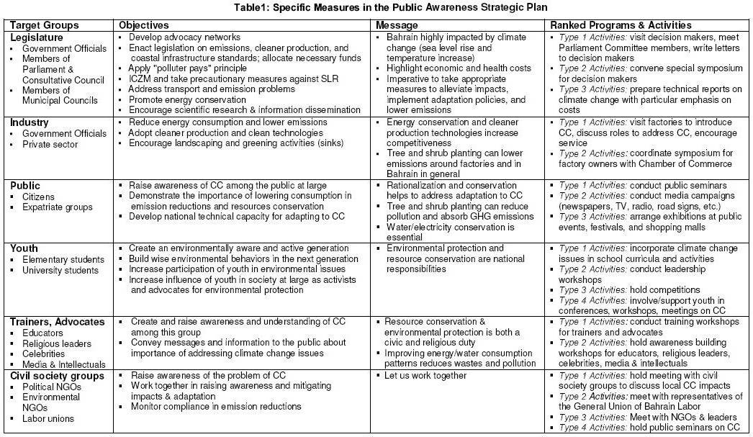

3.3.3. Yemen National State of Environment Report (SoE-2001):

Introduction:
Yemen Environment Protection Authority (YEPA) took the initiative to produce a State of Environment for Yemen every 5 years. The first report was produced in 1995 and the second was completed in year 2001. Although it is was mainly concerned about the biophysical environment, the report highlighted the new institutional environmental management structures, provided information about the population, urbanization, agriculture, water resources, coastal and marine environment, as well as biodiversity and cultural heritage of the country. The report also identified a number of critical issues and provided remedial actions to deal with the environmental problems stemming from the nexus of population growth and resources exploitation. Within the context of the analysis the report tries to answer the question "What is happening to the Yemen environment?".

Step 1: WHY, Impact Statement, what the YEPA wanted to see changed.
The SoE report begins by establishing the context of the assessment. The Ministry of Environment and Tourism (YEPA) has decided to put in place a comprehensive assessment of, and report on the state of the environment in Yemen. The stated objectives were:
  - The traditional State of Environment (SoE) reporting activities should provide information on the environment and the trends of its key variables.
  - The collected information should be objective, accurate, credible and scientifically analyzed, so that it could build and gain trust of the various stakeholders.
However, the proponents of the report were cognizant of the fact that, the end result of environmental assessment should be more than just knowing the state of the environment. And that such national assessment reports should provide the policy-makers and interested stakeholders appropriate guidance, (a focus on change) on how to better manage the environment. In order to achieve this, information obtained from such reports should be integrated with other social and economic data to assist in formulation of stronger environmental policies and programmes based on the knowledge of the Yemen environment.
The growing interest in linking environmental, social and economic data information within the context of sustainable development facilitates integrated analysis of the complex interactions between people and their environment.

Step 2: WHO are the key actors, and how to build relationships with them?
Although, right from the beginning of the SoE process, an effort was made to plan and execute a strategy that would help and sustain stakeholder's interest and participation throughout the assessment processes. The communications strategy lacks the specificity of an impact strategy with respect to the identification and building of relationships with key actors. The strategy identified generally only one target audience, namely: the "stakeholders". However, the strategy itself was largely silent on the general categories of stakeholders, (for example, government officials, elected representatives, NGOs and private sector), and the most effective and appropriate channels to reach out and engage their attention. The command and control policies of the government directive in making available the findings and results of their assessment clearly delayed the timely accessibility of such reports by the concerned parties.
Information by itself doesn't leverage change, but relationships do, and this involves people communicating ideas, analysis and data to other people. This step involves identifying the individuals and groups you most want to reach. Central to determining who to reach is the concept of relationship management: maintaining the connections and influence overtime. The assessment specifically lacks relationship management approach. For the future, the communications activities must clearly demonstrate how such reports will impact on various stakeholders.

Step 3: WHAT knowledge is to be gathered?
Although the process of preparing the Yemen SoE report was a major undertaking by theYEPA, the report doesn't specify the details of how the data was collected and analyzed. But the management of the report identifies the environmental status report of 1995 as the base for the information collected since it is considered an important year in the process of environmental planning and the progress made in formulating environmental policies and legislations. However, the proponents of the report refer to the problem of data availability, "despite the non-availability of adequate information on natural resources present levels of exploitation and the growing demand by the population and development needs, the report still reflect an approximate picture of the environmental conditions and status in Yemen, and that the YEPA will cooperate with other government agencies to collect environmental data in order to monitor future changes in the state of the environment. In spite of these data shortcomings the report identified a number of critical environmental issues and their interlinkages with pressures causing degradation, and recommendation to conserve and environmental management of these resources

Conclusions:
The proponent of the report – thought that by producing the SoE report they have – achieved success in moving many issues into the hands of the decision-makers. And have further succeeded in producing the following:
1- Preparation of the National Environmental Action programme, in collaboration and participation of the local and central governments members, national experts, representative of private sector as well as NGOs, which provided effective support.
2- Consideration of environmental issues in social and economic development plans (1996- 2000 and 2001-2005).
3-Mandatory preparation of Environmental Impact Assessment (EIA) for all development projects
4- Preparation of National Strategy and Action Plan for biodiversity in Yemen.
5-Enactment of the Environment Protection Law, and effective application of policies and programmes to address/respond to local and regional Yemeni environmental issues identified by the SoE report
6-Formulation of a number of recommendations for strengthening institutional structures, capacity building and environmental policies and programmes
7-Ratification of a number of International Environmental Agreements
8-National Communication for Climate Changes in Yemen

GROUP DISCUSSION

- What do you think are the strengths and weaknesses of the impact and communications efforts of these examples?
….……………………………………………………………………………………
……………………………………………………………………………………….
……………………………………………………………………………………….
EXERCISE 5: Building an Impact Strategy
The participants will break up into smaller groups. Based on the training materials presented and ideas discussed using the case studies, the participants will be able at the end of this session to prepare a draft of the impact strategy. Throughout the remainder of the workshop, the draft strategy (ies) will be revisited, and you will be asked to consider whether and how to revise and strengthen your strategy (ies).
If you are participating in this training with your IEA team, then this might become a draft strategy that will be useful to you in your IEA process. If you are working in mixed groups or with people that you would not work with for your real assessment, this will be an activity to practice the steps.
Please select a chairperson and a rapporteur who can capture and present your results in plenary.

Step 1: Drafting the impact statement

Prepare an impact statement and a general list of purposes for the assessment.

Smaller group exercise

- Discuss within the group what you specifically want to see changed as a result of your assessment.
- Prepare a statement of the impact that you want your assessment to have.
- Write the statement on your flip chart under the heading Step 1.

Step 2: Identification of WHO you are trying to have an impact on.

- Identify the key actors who are in positions to make the changes that you would like to see.
- How do decision-makers acquire information? What do they trust? Who do they trust? How to get to those people?
- Broader audiences, others connected to the key actors. This is the community of interest who you may wish to work with your findings.

Smaller group exercise:

- Discuss within the group:
- Why do you want to reach them?
- How feasible is it that you can reach them?
- Are there other people who can reach them better than you can? Who might they be? .

Step 3: Discussion of WHAT knowledge you need to collect and how that knowledge collected.

- The major contribution of this training program is to provide you with tools to gather the appropriate information and the means to collect it. When building the influencing strategy, it is important to understand that what you want to learn may not be what a decision-maker needs to know. The step deals with the question of legitimacy, and equitable participation
- Building trust in the final product in your data. Being aware of the tradeoffs? Participation of the target for saliency; participation of scientists for credibility; participation of local communities/indigenous for legitimacy. Think about the difference between modes of participation.

Full Group Discussion:

- What are the different ways you can build trust with people?
- How will you find out more clearly what your key actors need to know, what their interests are and how the information will be of use to them?

Smaller group exercise:

- Prepare 2-3 statements of the information you intend to collect for your assessment. Write these on your flip chart under the heading Step 3.
- Prepare a short description of how you will interact with your key actors during the assessment period.

Step 4: Planning HOW to bring the report to the attention of key actors

You need to think about the tools and tactics you can deploy to bring the report to the attention of the target people you have identified, and to others who may be able to influence them. The step covers the following areas:
- Opportunities,
- Revisiting the issue cycle,
- Mapping the landscape,
- Creating and seizing opportunity.
There are broader ranges of opportunities to deliver your findings. These include:
- Workshops
- Formal presentations to departmental and parliamentary committees.
- Meetings with representatives of NGOs.
- Exclusive events with private sector interests to discuss how the assessment is relevant to them.
- Website publications.
- Electronic conferences to discuss findings.
- TV and radio interviews.

Group discussion:

Communication channels and delivery techniques are important. But you also need some key messages.

- In the group, discuss what 2 or 3 key messages might be from previous assessments you have worked on. What were some of the strengths and weaknesses of these? If you have not worked on an assessment before, think about what the key messages might be from one of the case studies discussed in Section 2. What might be the key message for your new assessment? Under the heading Step 4, record one of the key messages.
- Discuss three approaches that you might take to promote your messages and findings to your key actors, and to broader audiences and the general public all of whom can influence your key actors on your behalf. List these approaches under Step 4 on your flip chart.

Pulling the Strategy together:

This part of Step 4 deals with the task of comparing your impact strategy with those of other groups. The task includes comparison of your impact statements, who the strategy is targeting, what knowledge needs to be collected, and how to bring the results of the report to the attention of key actors.

Smaller group presentation of Steps 1-4.

- Share your Steps 1-4 with the rest of the training group.
- Post the flip charts for each step together so that groups can see the variations in impact statements, key relationships and so forth.

This is your very rough master outline, and it will give you a sense of what your impact strategy for your assessment might become. Now you need to review and refine it.

Group discussion:

- On the Impact Statement:
  - Can the impact statements be combined into one comprehensive statement that is still focused on change?
  - Is there a general acceptance of the impact statement by the group?

- On WHO the strategy is targeting:
  - Are there any other individuals or groups that should be added to the list?
  - Media: have you included the key journalists who are influential in your country?
  - NGOs: have you included the key NGOs who might help to promote the assessment recommendations?
  - Now that you have selected the key actors, what are some of the broader groups you should reach out to? What about women’s groups? Can they become supporters of your work? What about village councils and district authorities? What about Chambers of Commerce? What about youth organizations?

- On WHAT:
  - Discuss challenges you may face in engaging your key actors in order to understand what those actors need to know
- On HOW:
- Messages depend on the results of your assessment.
- Do any of these messages relate to issues that are relevant to women? How can you craft a message that will reach women effectively?
- Are there any other possible channels for communication? Have you thought about channels that will reach women? Young people? And people living below the poverty line? How will you reach some of the broader groups like village councils and district administrations?

Step 5: Monitoring, evaluation and improvement of your impact strategy

Monitoring and evaluating mechanisms are essential signals that will tell you whether your strategy is having impact.

This section covers:

What do you want to monitor throughout the process to see whether you are in fact having an impact? For example:

Actual participation in discussions and meetings
- Increased demand for assessments; for interpretations of findings from assessments
- Looking for change in interaction and recording comments
- Meetings with users to get their feedback.
Group discussion
- What are some indications that you are influencing your key actors?
- What are some ways that you can keep track of your performance on the strategy?

Group discussion:

Preparing, implementing and monitoring an impact strategy are not a simple task it takes time and effort. What resources do you think might be required to implement this strategy? If your resources were limited, what would be t he most critical elements that you would implement? Are there any partnerships you could form to help you? For example, how might you work with your government communications department?
Final Group discussion
What does your group as a whole think of the draft strategy? What are its limitations? What are its possibilities?

4. Pilot Training Plan

4.1. Understanding the Impact Process:
Workshop leader / facilitator presentation
- Why it is important
- Understanding the context (issue cycles); how to recognize an issue cycle [media, polling data, etc.]
Facilitator leads group discussion:
- What is the context for your assessment?
- Why has this been mandated?
- What is your political context?
- What are the current major issues in your country right now?

4.2. Explanation of the Impact Strategy model:
- Facilitator presentation of the model, with reference to the case study.
- Break out into groups, discuss a success story from their own experience, roles of different players, what was their role?

4.3. Building an Impact Strategy
Participant activity in smaller breakout groups
Note: If the training group consists of participants all working on the same national assessment, then participants can either chose which breakout table they want to work at, or the facilitator can assign them to groups. If participants represent several countries, or departments or organizations undertaking different assessments, then breakout groups should be organized by country or by department/organization.

Facilitator explains that at the end of the session, the participants will have prepared a draft impact strategy. Throughout the remainder of the workshop, the draft strateg(ies) will be revisited, and participants will be asked to consider whether and how to revise and strengthen their strateg(ies).

4.3.1 Drafting the impact statement
Facilitator: More detailed explanation of the impact statement; suggest possible general purposes of an assessment
Each person in the breakout group is asked to:
- Describe a situation that will be better as a result of your assessment
- What do you specifically want to see changed as a result of your assessment?
- Group then prepares a statement of the impact that they want their assessment to have.

4.3.2 Identification of WHO they are trying to have an impact on.
Facilitator: Further comments on WHO:
Groups are then asked to:
- List 10 key actors they most want to reach with their assessment findings
  - Why do they want to reach them?
  - How feasible is it that they can reach them, or do they have to identify “intermediaries”?

4.3.3 Discussion of WHAT knowledge they need to collect and how that knowledge is collected:
Facilitator: Repeat explanation of “What”, followed by brief explanation that the balance of the capacity building workshop will provide more tools for what information to gather and how to collect it. This section is to focus on questions of building trust, legitimacy and participation. Participation of the target for saliency; participation of scientists for credibility; participation of local comm./indigenous for legitimacy.

Group discussion as a whole:
- How to build trust with the 10 people you have identified; how to find out more clearly what those 10 people need to know.

Groups are then asked to:
- Prepare 2-3 statements of the information you intend to collect for your assessment
- Prepare list of others needed to be involved in assessment process [nb, is this getting into territory covered by Process module?]
- Prepare description of how you will interact with all of these people during the assessment period [engagement]

4.3.4 Planning HOW to bring the report to the attention of targets
How to bring the report to the attention of the 10 target people they have identified and to others who may be able to influence the 10.

Facilitator: More detailed explanation of “HOW”;
- Key messages; broader audiences; channels to use
- Provide samples of key messages.

Differentiate between this strategy, and module 7. There will be a number of mandated outputs required from the assessment; module 7 focuses on the technical production of those outputs.

Groups are then asked to:
- Draft 2-3 key messages from previous assessments you have worked on.
- Describe three approaches that you might take to promote your messages and findings to the 10 people, and to broader audiences who have influence.

4.3.5 Pulling the Strategy together:
Facilitator:
- Asks each group to present their strategy.
- Combines the strategies into one draft strategy

Note: this assumes that the workshop is being held at a country level, with only one assessment being planned. If the training group includes participants from a number of countries or if participants represent departments or organizations undertaking different assessments, this last step, the combination of strategies, can be skipped.

Group review of each component of the strategy as they are combined:
- On the impact statement: any further considerations? General acceptance of the impact statement by the group? Note exceptions or variations in opinion.
- On WHO the strategy is targeting: combine the names of the 10 key actors[increase the list to 20?], but then ask the group for additional names in categories they may have overlooked:
- Media: names of key journalists
- NGOs: names of key people in NGOs who might help to promote the assessment recommendations
- On WHAT: any further considerations? Discussion of challenges the group may face in engaging the 10+ people in order to more clearly understand what those 10+ need to know; and challenges in working with others involved in the assessment (scientists, local communities, etc.). FLAG GENDER CONSIDERATIONS here: women included in the process? Women in the target group?

- On HOW: Remind group that messages depend on results of assessment. Group review of proposed approaches; suggestions for additional channels for communication. FLAG GENDER CONSIDERATIONS HERE: messages designed to reach women?

4.3.6 Monitoring and assessing the effectiveness of the impact strategy (ies)
Facilitator:
- Short presentation on why one needs to monitor for success and how to monitor impact.
Group discussion as a whole:
- Propose sample indicators to monitor for success of the strategy

4.3.7 Checkpoint:
What resources might be required to implement this strategy? Creative solutions (eg, Working with their government communications department) If their resources are limited, what would be the most critical elements that they would implement?

4.3.8 Final Group discussion
What does the group think of the draft strategy? What are its limitations? What are its possibilities?

__References
Agrawala, S. 1997.Explaining the Evolution of the IPCC Structure and Process.E-97-05, Belfer Center for International Affairs, Harvard University, Cambridge, MA.
Global Environmental Assessment Project. 2005. Harvard. www.ksg.harvard.edu/gea
Downs, A. 1972. Up and down with ecology- the issue- attention cycle. Public Interest. Summer 1972, pp.38-50
Jager, J. and A. Farrell, eds. Global and Regional Environmental Assessment: Design and Practice. Forthcoming.
International Institute for Sustainable Development. 2002. Sustainable Development Timeline. 3rd edition. Winnipeg, IISD.
International Institute for Sustainable Development. 2004. The IISD Influencing Strategy.
Earle, S., F.Carden and T.Smutylo. 2001. Outcome Mapping: Building Learning and Reflection into Development Program. IDRC, Ottawa, Canada.
Environment Protection Authority, 2001. Report on the State of Environment in Yemen (Year 2001). Ministry of Tourism & Environment, Republic of Yemen (in Arabic)
Khalil, Anwar, S. 2004. Education, Public Awareness and Training. Desert and Arid Zones Sciences Programme, College of Graduate Studies, Arabian Gulf University, Manama Kingdom of Bahrain.
General Commission for the Protection of Marine Resources, Environment & Wildlife. 2005. Bahrain’s Initial Communications to the United Nations Framework Convention on Climate Change, Volume 1: Main Summery Report. Manama, Kingdom of Bahrain
Creech. C., J. Jaeger. N. Lucas. M. Wasstol. And J. Chenje. 2006.
Developing an Impact Strategy for your Integrated Environmental Assessment. Training Module 3.
GEO Resource Book, UNEP, IISD, Nairobi, Kenya.
Social Learning Group, 2001. Learning to Manage Global Environmental Risks. MIT Press, Cambridge, MA.
OFID, 2007. Research on Climate Change; OPEC nations pledge financial resources. OFID Newsletter. The OPEC Fund for International Development, Austria, vol.XIII (Oct-) Dec.2007.www.opecfund.org/puplications/PDFf/13.3.pdf/NL/NL
Zubari,W.K., Anwar,S.Abdu., Asma,A.Abahussain. Nadir,A.M.Mosa. 2004. Environmental Awareness Programme for the Climate Change Project in the Kingdom of Bahrain. General Commission for the Protection of Marine Resources, Environment and Wildlife, and the Arabian Gulf University, Kingdom of Bahrain,(in Arabic).

