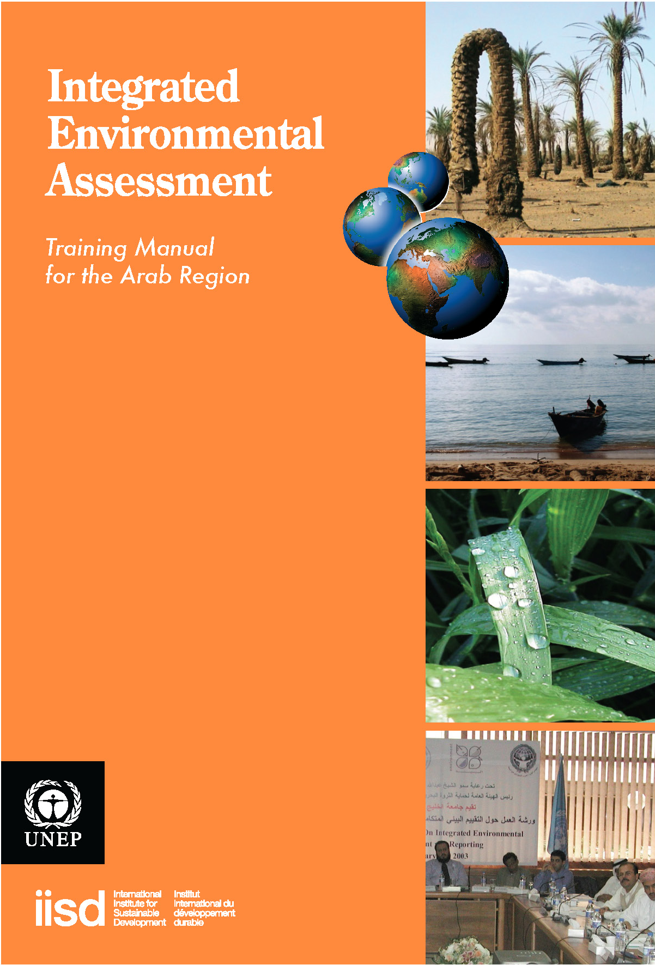
Module 8

Monitoring, Evaluation and Learning for Improvement and Increased Impact of the IEA Process

Authors:
Andrea Déri, LEAD International, United Kingdom
Darren Swanson, IISD, Canada
Preeti Bhandari, TERI, India

Localization:
Mohamed S. Abido (Damascus University)

Editorial Support:
Mona Radwan, UNEP
Mayar Sabet, CEDARE
Tarek Abdel Monem, CEDARE
Yusuf Emad, CEDARE

Translation Team:
Yasmine Zaki
Rajia El Bialy

Table of Contents
List of Acronyms iv | iii
Overview 1 | 1
Course Materials 3 | 3
1. Introduction 3 | 3
1.1. Definitions 3 | 3
1.2. Competencies 4 | 4
1.3. Rationale 5 | 5
1.4. Examples 6 | 6
2. Foundation of effective monitoring and evaluation 8 | 8
2.1 Purpose 8 | 8
2.2 Users | 9
2.3 Evaluators 10 | 10
3. Framework, attributes and measures 11 | 11
3.1 Attributes of effective assessments 11 | 11
3.2 Framework 12 | 13
3.3 Measures  3.3.1 Outcome-based Measures for Improvements in Policies and Policy Processes  3.3.2 Outcome-based Measures for Effective Relationship Management  3.3.3 Activity and Output- based Measures for Effective Knowledge Management  3.3.4 Activity and Output- based Measures for Effective Opportunity Management  3.3.5 Measures for Timely Completion of Key Activities and Outputs | 15  15  15  17  18  19
4. Self-assessment matrix | 20
4.1 Step 1. Identify major issues and monitoring questions, and develop  specific measures | 21
4.2 Step 2. Identify sources of data and data collection methods | 24
4.3 Step 3. Set priorities and frequency of monitoring and evaluation | 27
5. Improvement opportunities | 29
5.1 What do we call learning? | 29
5.2 How can we recognize learning opportunities? | 31
5.3 How can we use learning opportunities? | 31
References | 34

List of Acronyms

EMS | Environmental Management Systems
GEO | Global Environment Outlook
IDRC | International Development Research Centre
IEA | Integrated Environmental Assessment
NHI | National Host Institution
SHI | State Host Institution
SoE | State of Environment
SWOT | Strengths, Weaknesses, Opportunities and Threats
TQM | Total Quality Management

Overview
How many of your policy-makers use integrated environmental assessments (IEA) as a trusted resource, and consider it a learning opportunity to improve policies? How do we know whether the assessment is useful and used, rather than just sitting on a shelf? Module 8 offers tools to help you monitor and evaluate the effectiveness of your national or sub-national IEA.
In Module 8, you will learn to develop a monitoring and evaluation plan, based on seven questions:
1. What is the purpose of the evaluation?
2. Who will use the evaluation results?
3. Who will do the evaluation?
4. What evaluation framework is practical?
5. What needs to be monitored and evaluated?
6. What are the steps to develop a self-assessment matrix?
7. How can you use the evaluation to enhance a learning culture that keeps improving your IEA process?
Module 8 promotes an improvement-oriented evaluation that aims to increase the effectiveness of your national or sub-national IEA process by feeding lessons learned into the next cycle. Learning plays a central role. It shapes the monitoring and evaluation process, and keeps knowledge creation connected with policy making.
Module 8 challenges you with two questions:
1. How to make sure your IEA has an evaluation component?
2. How to design an effective evaluation that keeps improving your IEA process?
As part of designing an effective evaluation, you will develop measures to monitor and evaluate key outcomes from your IEA—relating to the change statement from your impact strategy and the important relationships you need to manage to achieve impact (Module 3). You will also develop measures to monitor the timely completion of key activities and outputs of your IEA process—relating to the important knowledge you will generate in your IEA and the opportunities you need to leverage in order to effectively communicate the results of your IEA to your target audiences.
For Module 8, you need to be familiar with the stages for developing an IEA (Module 2) and your impact strategy (Module 3).
Notes
..........................................................................................................................................
..........................................................................................................................................
..........................................................................................................................................
..........................................................................................................................................
..........................................................................................................................................
..........................................................................................................................................
..........................................................................................................................................
..........................................................................................................................................
..........................................................................................................................................
..........................................................................................................................................
..........................................................................................................................................
..........................................................................................................................................
..........................................................................................................................................
..........................................................................................................................................
..........................................................................................................................................
..........................................................................................................................................
..........................................................................................................................................
..........................................................................................................................................
..........................................................................................................................................
..........................................................................................................................................
..........................................................................................................................................
..........................................................................................................................................
..........................................................................................................................................
..........................................................................................................................................
..........................................................................................................................................
..........................................................................................................................................
..........................................................................................................................................
..........................................................................................................................................
..........................................................................................................................................
..........................................................................................................................................
..........................................................................................................................................
..........................................................................................................................................
..........................................................................................................................................
Course Materials
1. Introduction
In Section 1, you will learn about the basic definitions and terminology used in this module.
Examples from national, regional and global levels will support the rationale for monitoring and evaluation with a national IEA based on the GEO approach.
1.1 Definitions
The monitoring, evaluation and learning guidelines suggested in Module 8 refer to the national IEA process described in Module 2, presented here in Figure 1. Module 8 argues that in order to have the desired policy effects, you need to monitor and evaluate the process, products and impacts, and use your lessons learned in planning and improving the next IEA cycle.

Figure 1: Stages of National IEA Process – Monitoring and Evaluation Marked in Grey

Monitoring and evaluation of an IEA process and its impacts focuses on how the assessment process has been organized to have a desired impact on policy making.
Let’s understand how monitoring, evaluation and learning can be used as complementary tools that build on each other’s impact to improve an IEA process (Table 1).
Monitoring is a planned, systematic process of observation that closely follows a course of activities, and compares what is happening with what is expected to happen. Monitoring the IEA process makes sure the environmental assessment meets its goals, while working within the scope of allocated resources (i.e., time, financial, human, informational and technical).
Evaluation is a process that assesses an achievement against preset criteria. Evaluations can have a variety of purposes (Section 2.1), and follow distinct methodologies (process, outcome, performance, etc). Evaluation of the IEA process determines the extent to which achievements (outputs, outcomes and impacts) are comparable with the originally intended purpose, and what lessons can be learned for the next environmental assessment and management cycle. The evaluation of the process is, first and foremost a capacity-development opportunity.
Attribute | Monitoring | Evaluation
Main focus | Collecting data on progress. | Assessing data at critical stages of the process.
Sense of completion | Sense of progress. | Sense of achievement.
Time focus | Present | Past – future.
Main question | What needs to happen now to reach our goal? | Have we achieved our goal?  How can we do better next time?
Attention level | Details. | Big picture.
Inspires | Motivation. | Creativity.
Periodicity | Continuous throughout the whole process. | Intermittent; at the beginning or end of significant milestones.
Supports | Implementation of a plan. | Designing the next planning cycle.
Skills required | Management. | Leadership.
Output processing | Progress indicators needs to  be closely monitored by a few people | Evaluation results need to be discussed, processed and interpreted by all stakeholders.

Learning is an emotional and/or cognitive transformation taking place during information collection and information processing. Learning brings about behavior change or in the ability to act differently. Learning can happen whether it is intended or unintended. Monitoring and evaluating the IEA process offer learning opportunities. Planning for and making use of these learning opportunities can bring about lessons that comprise key inputs to improve an iterative IEA process. Missing these learning opportunities decreases the influence of the IEA process on policy making.
1.2 Competencies
Upon successfully completing Module 8, you will be able to:
- explain the importance of monitoring and evaluating;
- recognize monitoring and evaluation as learning opportunities for improving your IEA process; and
- develop a draft plan for monitoring and evaluating your national IEA process and its impact.
1.3 Rationale
As part of developing a rationale for monitoring and evaluation plan, reflect on your earlier experience with any kind of evaluation: what worked for you, what did not (1)? What are the constraints you have in your organization regarding evaluation (Exercise 2)?
Exercise 1: Previous experience with monitoring and evaluation
The purpose of this exercise is to share previous experiences in monitoring and evaluation.
In plenary, ask if anyone has had a positive experience with monitoring and evaluation. Request that two or three volunteers briefly share their experiences. Make a list of what made the evaluation experience positive, and use this list in the next steps of designing the evaluation of your IEA process.
Time: 15 minutes.
Exercise 2: Constraints
The purpose of this exercise is to map constraints that organizations have in monitoring and evaluation.
In small groups, ask participants to point out areas of the IEA process where their organization could have constraints that could limit monitoring and evaluation. Compile the constraints, putting them on an enlarged IEA process chart for later use.
Time: 20 minutes.

The idea of monitoring and evaluation typically brings about more apprehension than applause. Negative associations, ranging from the trouble of an extra budget line to the fear of inadequacy, lead to people not using evaluation results, not learning from them and thus not seeing their value in improving a process.
Further reasons for disregarding evaluation, especially in the IEA process, lies in mistaking outputs (i.e., products such as the IEA report) for outcomes (i.e., improved policies for environment and development), and in seeing little added value in evaluation as long as a tangible, credible and legitimate state-of-the-art report gets published on time. No wonder that monitoring and evaluation are often cut out of the work plan and the budget.
Given that, why does it remain important to pay attention to monitoring and evaluation?
Monitoring and evaluating the IEA process attracts attention when you want to make sure your process gets used, especially in policy improvement. Figure 2 illustrates how improvements in policy making procedures, policies and in the state of the environment can be driven through monitoring and learning.
In this context, the IEA process is regarded a capacity development mechanism for periodic policy revision and improvement. This approach acknowledges that information itself is not enough; dedicated mechanisms (see impact strategies, Module 3) are needed to facilitate the uptake of IEA information by policy reviews. Moreover, it recognizes that institutional improvement can only happen with concurrent improvements in both individual capacities (e.g., policy-makers’ understanding of environmental issues) and organizational capacities (e.g., higher level of efficiency and the ability for organizational learning).
From this view of institutional improvement, it might be easier to recognize that developing internal capacities in monitoring and evaluation, the purpose of Module 8, adds value to and remains an essential component of the IEA process.
Figure 2: IEA as a Capacity Development Process Linked to Policy Improvement

1.4 Examples
The SoE reporting system in India provides a good example where monitoring and evaluation became a tool to make the national process a success (Box 1).Monitoring and evaluation increased the perception of saliency (i.e., of current importance), credibility (i.e., can we believe the results) and legitimacy (i.e., can we trust the results) of the environmental assessment. In India’s case you can see a systematic effort to embed SoE reporting in state-level governance to addresses environmental issues (e.g., in Punjab, Kerala and Chandigarh), and to strengthen capacities at the level of individuals, organizations (e.g., state and national lead agencies) and institutions (i.e., evidence based policy making).

Box 1: SoE Reporting, India – Monitoring and Evaluation of a Reporting Process
The SoE reporting system of India has been monitored and evaluated closely, with the aim of embedding the reporting system in the practice of state governments. This ongoing programme involves building capacities for the preparation of SoE reports within the state/regional institutions and governments and the national government, and supporting triennial SoE reporting by state and national governments.
The process was carefully designed. Only a few expert institutions, designated national host institutions (NHI), were given the responsibility of identifying state host institutions (SHI) and building interest and capability within those SHIs to undertake SoE reporting. Beyond training, NHI also review progress made by SHIs in developing their products, provide expert input on the frameworks of analysis and critically analyze the products before final publication.
SHIs are responsible for identifying and mobilizing partners, facilitating a participatory process, collecting and analyzing information, interacting with NHIs and developing SoE products.
At the national level, the Indian Ministry of Environment and Forests, the lead ministry for the programme, periodically evaluates the progress made by NHIs and SHIs through review meetings. Funding is tied to the demonstration of progress.
A two-stage monitoring and evaluation process is in place. The NHIs’ performance evaluation (done by the ministry) is linked to the level of success they achieve, as indicated by the number of states that have made significant progress towards establishing systems for SoE analysis, and for publishing a final SoE report. The second element relates to the linkage between NHI and SHIs, and it is only through NHI certification that an SHI receives funding. In this case, the tangible indicator is the SoE report, but interim continuity in the process is ensured by the NHI, as their ultimate evaluation is based on the number of reports they supported. As for the imperatives at the state level, a careful selection of SHIs is essential for the success of this programme. A proactive SHI, with its linkages and wherewithal, will ensure a close monitoring of the actors/institutions involved, and will deliver results.
Overall response to the programme has been mixed, but SHIs that have taken this initiative seriously are establishing benchmarks for all states, even those that are less responsive. Some progressive states, such as Punjab, Chandigarh and Kerala, have successfully produced SoEs, and are working towards their next products, focusing on emerging environmental challenges.

Monitoring and evaluation of an IEA process enhances communication between the cycle of scientific data collection and processing, and the cycle of policy making. This “coupling” function can help to ensure that evidence originating from either scientific or indigenous knowledge is fed into policy making early enough. Because it can take decades and a series of political cycles to develop the right set of policies after discovery of the first evidence of an emerging environmental problem, the role of monitoring cannot be overstated.
Without an impact strategy (Module 3) and monitoring and evaluation (Module 8), the IEA process could run the risk of not being able to influence policy making.

2. Foundation of Effective Monitoring and
Evaluation In Section 2, you will start developing your monitoring and evaluation plan in three steps. First, you will learn about different purposes of evaluation, then decide the purpose of yours. Second, you will identify the primary users of your evaluation, people whose perception is critical as to whether your evaluation gets used and fed into the planning cycle. Third, you will decide whether external or internal evaluators serve best your purpose.
2.1 Purpose
With regard to intended purpose, there are three fundamental types of evaluation. They can: render judgment, encourage improvement and generate new knowledge (Patton 1997).
Judgment
Summative evaluation, accreditation, quality control and audits are examples of judgment-intended evaluations. They follow a deductive method by setting clear criteria and standards with which to judge performance, often using quantitative measures. Judgment-intended evaluation often is commissioned by external parties (e.g., donors), and typically is performed by external evaluators. Such evaluation could increase the credibility of an IEA process, given its impartiality and objectivity.
Improvement
Formative evaluation, empowerment evaluation (Fettermann 1996) and outcome mapping (Carden 2001) are examples of improvement or development-minded evaluations. The central intent of this type of evaluation is making things better over time. Improvement evaluation is inductive, posing open-ended evaluation questions. Evaluators are often internal; the participants, including some of the primary users, conduct the evaluation. SWOT analysis (Strength, Weaknesses, Opportunities and Threats), TQM (Total Quality Management), EMS (Environmental Management Systems) and ISO 14001 employ the evaluation of improvement approach. Improvement-intended evaluation could increase the legitimacy of the IEA process, given its users’ perspective.
Such evaluations often are applied to cyclical activities, like the IEA process, where performance improvement is expected over time. This improvement can involve change in behaviour (e.g., improved communication) or change in the state of the environment (e.g., improved water quality).
Outcome mapping (Carden 2001) focuses on changes in human behaviour, values, skills and knowledge, and acknowledges the complexity and the life cycle of the outcome. Some outcomes (e.g., institutional transformations) need decades to fully develop.

Knowledge creation
Knowledge-oriented evaluation—exemplified by action research, case studies, lessons learned and policy recommendations—has been gaining attention recently because of its capability to generate innovative ideas and deep insights for the intended users. Emerging knowledge can improve a known process, and break new ground. Evaluators can be both internal and external, and the intended users are actively engaged all along. Knowledge-oriented evaluation can increase the saliency of the process, given its potential to generate new knowledge that the user needs for a pressing decision (Bernd Siebenhüner 2005).
In reality, elements of all three categories can be found in an evaluation. For practical purposes it is important to select and focus on one dominant approach from the onset. As an IEA process intends to influence the policy and decision making processes, which generally happen in predictable cycles, a predominantly improvement-oriented evaluation is recommended.

Discussion Questions 1
1. Why do you need to plan for monitoring and evaluating your IEA process and its impact at the beginning of the planning process?
2. Why is improvement-oriented evaluation relevant to your IEA process?
Having decided on the intended purpose of your evaluation, the next step is to clarify who has interest in using the evaluation findings (users), and who will eventually implement the monitoring and evaluation (evaluators).
2.2 Users
The users of an IEA-type evaluation are individuals who:

- can revise the IEA process: have the mandate, knowledge and skills; and
- want to revise the IEA process: have a vested interest in influencing the design and implementation of the IEA process.

Identifying the users is perhaps the single most important step for getting the evaluation utilized. If you know who the users are, what decisions they have to make, and how the evaluation results can support their decisions, you can attract the users’ attention and increase the uptake of evaluation results.

The primary users of the evaluation may include:

- IEA core team (may include policy-makers);
- policy and decision-makers in the broad sense (the primary users of the IEA); and
- the evaluation team (internal and/or external).

The IEA core team (Module 2) often includes policy-makers; some of them are active and demand information, while others tend to be passive and pleased to be informed whenever information is available. The more active they are, the more interested they may be in your evaluation.
Often, the success of the entire IEA process depends on a single person in the government who is committed and driven. Involvement of this individual in the core group (the group that is the primary user of the monitoring and evaluation), is critical (Exercise 2).
Exercise 3: Identify the users
The purpose of this exercise is to identify the primary users of monitoring and evaluation of the IEA process.
1. Ask participants to list the names, positions, and departments of potential primary users of the results of monitoring and evaluation. (Small groups Time: 5 minutes.)
2. Ask participants to record the interest of these potential primary users in using the monitoring, evaluation and impact data, and if they have the mandate for revising the IEA process. (Small groups Time: 5 minutes.)
3. Have 2–3 small groups report on their candidates, and compare results. (Whole group
Time: 10 minutes.)
Total time: 20 minutes.
2.3 Evaluators
The purpose and the users of your evaluation will shape your preference for internal or external evaluators. A combination of internal and external evaluators is the ideal solution, as it benefits from the dedication and insight of internal members, and the impartial objectivity of external observers and peer reviewers.
Evaluators may include:
- A small internal evaluation task force (including the IEA core team, which is recommended).
- External evaluators (consultants and internal evaluators of another IEA).
- A combination of internal and external parties.
In reality, ministries are often chronically understaffed or challenged by lack of capacity, and forced to use external evaluators. In this case, regular contacts between the external evaluator(s) and the IEA core team are essential throughout the IEA cycle.
Evaluators are selected by the IEA core team. They should have a good understanding of the IEA process, its intended impact and societal contexts. (Exercise 4)
Exercise 4: Identify the evaluators
The purpose of this exercise is to identify the evaluators of monitoring and evaluation of your IEA.
1. Ask participants to decide on and justify the types of evaluators they would use for monitoring and evaluation: external, internal or a combination. Ask for suggested names, if possible. (Small groups Time: 10 minutes.)
2. Initiate whole group discussions. (Whole group Time: 10 minutes.)
Total time: 20 minutes.
3. Attributes, Framework and Measures
Section 3 covers the attributes that will indicate the effectiveness of the IEA process and selecting an evaluation framework. Then it will discuss formulating the key evaluation questions, and measures that will help you collect data for monitoring and evaluation.
3.1 Attributes of Effective Assessments
This framework takes a look at key attributes that enhance the IEA report’s effectiveness in influencing policy-makers. The notions of saliency, credibility and legitimacy—as key attributes of effective assessments—arise from earlier academic research that focused on better understanding the factors that determine the effectiveness of assessments (Box 2; Figure 3).

Box 2: Attributes of Effective Assessments
Through a five-year consultative process involving hundreds of professional evaluators internationally, the American Evaluation Association identified four criteria for effective evaluation: utility, feasibility, propriety and accuracy (Patton 1997). A couple of years later, the
Social Learning Group’s international research team arrived at a similar conclusion from a different point of departure, namely studying what makes environmental assessments effective, and what makes them utilized. The Social Learning Group found that the user
(i.e. policy-maker’s) perception of the assessment’s saliency, credibility and legitimacy was critical (Farrell and Jäger 2005).

Figure 3: Corresponding Attributes of Effective Evaluations

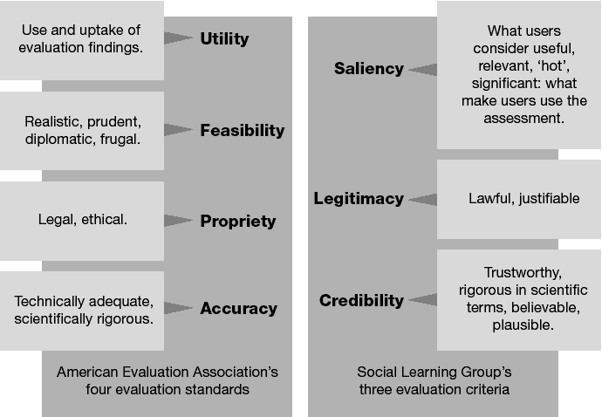

The saliency-credibility-legitimacy attribute triad acknowledges that the process is subject to political interests. We do not suggest that the process should bend to those interests, but emphasize the need to attract political attention when legitimacy and credibility are not convincing enough on their own merits. It also implies that without credibility and legitimacy, political saliency is not enough to attract and maintain attention.
The assessment of stratospheric ozone depletion is a good example, because it was perceived by policy-makers as salient, credible and legitimate:
- Salient. Because it addressed a global threat to survival that called for immediate attention and action from decision-makers.
- Credible. Because it involved high-profile research institutions from different countries, triangulating their observations and results.
- Legitimate. Because of the transparent process, engaging all relevant stakeholders and acknowledging their investment.
The Social Learning Group’s findings highlight another important point, the importance of involving user representatives which, in the case of an IEA, means key policy-makers. Through their participation in the assessment, these decision-makers can develop a sense of saliency in addition to being assured of credibility and legitimacy.
3.2 Framework
To design a monitoring and evaluating plan for your national IEA process, you must first develop a basic conceptual understanding of how the activities and outputs are linked with intended outcomes and impacts. Figure 4 provides such a conceptualization. As illustrated, the intended outcomes of an IEA process are the changes in the thinking and actions of policy-makers that can bring about improvements in policies and policy making processes, which, in turn, can result in environmental improvements. The ultimate goal is to maintain and enhance the health of ecosystems and the wellbeing of people.
Discussion Question 2
As a manager you know that you manage what you measure. What should you be keeping track of in your IEA process to manage it for the intended outcomes?
Given the limited time and resources available, it is crucial to be strategic in your efforts. The framework (Figure 5) represents one possible way to focus your evaluation and is based on the impact strategy framework from Module 3. This framework focuses on the extent to which the IEA process is effective in improving policies and policy making processes. With the goal of effectiveness, this framework requires that your monitoring and evaluation efforts go beyond the IEA report production cycle, to take a longer perspective and make a longer-term commitment.

Figure 4: Conceptual Understanding of the National IEA Process, With Links to Ecosystem Health and Human Well-Being

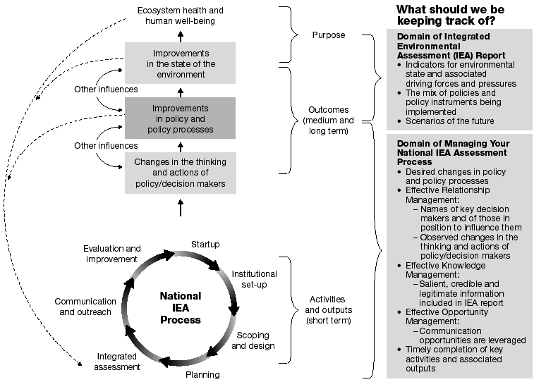

Figure 5: Framework for Monitoring and Evaluating the National IEA Process
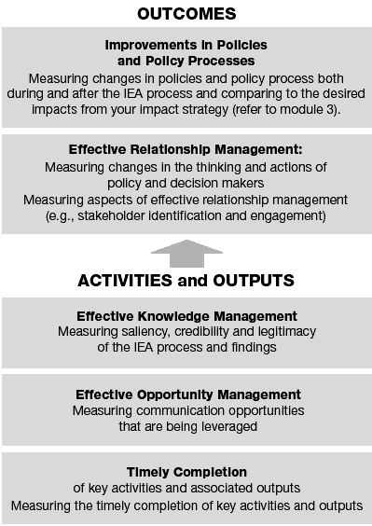

3.3 Measures
In the following paragraphs you will see five categories of measures you can use to monitor the effectiveness of your IEA process.
These measures will support the development of your self-assessment matrix (Section 4).
- Outcome-based Measures for Improvements in Policies and Policy Processes
- Outcome-based Measures for Effective Relationship Management
- Activity- and Output-based Measures for Effective Knowledge Management
- Activity- and Output-based Measures for Effective Opportunity Management
- Measures for timely completion of activities and outputs
3.3.1 Outcome-based Measures for Improvements in Policies and Policy
Processes
At the highest level of the monitoring and evaluation framework are measures necessary to track improvements in policies and policy processes. Measurement should relate to the change statement you identified in your impact strategy (See Module 3). An example is: “…the Poverty Reduction Strategy Paper planning and implementation process is adjusted to increase attention to environmental degradation, protection and rehabilitation based on the findings of the assessment.” Measurement should also track other observed improvements in policies and policy processes.
Attributing improvements in policies and policy processes to your IEA process will, in most cases, be a difficult or impossible task. It is not critical for these measures that you be able to attribute sole credit for the change to your IEA; what is most important is that the change occurred. Your measures for effective relationship management might still help you better understand the role of your IEA in higher-level policy improvements.
3.3.2 Outcome-based Measures for Effective Relationship Management
Relationships among people jointly processing and communicating ideas are what initiate change. Module 3 called for identifying those persons or groups of persons who are in positions to make the decision or to effect the changes you desire. While these persons could be considered a primary audience of an IEA, the people who lean in to whisper advice into the ears of the policy and decision-makers are also an important target audience with whom to build relationships.
Other important relationships to manage include people in civil society who can bring pressure to bear on decision-makers; those who can support, reinforce and strengthen your recommendations, in particular the academic community and other research institutes; and the media, through whom you reach the public and influence decision-makers.
Possible measures to monitor and evaluate for effective relationship management include the following (Table 2).

Table 2: Possible Measures for Effective Relationship Management
Key Question | Possible Measures | Possible Targets
Have key decision makers and potential influencers been identified? | Number of key persons identified for each relationship group, including specific names from each of the potential audience categories identified. | At least one key name per sector and discipline.
What important changes in the thinking and actions of key decision makers have been observed? | Types of Receiving behaviour observed (see  Module 3). Such as:  • Number of decision-makers as subscribers (individuals and organizations) to listserve/ e-mail newsletter.  • Receive and request SoE reports.  •Cell phone text messages.  • Number of PDF files downloaded from the national IEA website.  Types of Seeking behaviour observed (see  Module 3). Such as:  • Keywords entered into search engines of the national IEA website by decision-makers.  • Number of targeted users (key decision makers) attending new types of meetings and using IEA vocabulary in interviews with media.  (Policy-makers get IEA messages from media.)  Types of Acting behaviour observed (see  Module 3). Such as:  • Number of times IEA technical experts are contacted by decision-makers for consultation on budgeted activities.  Types of Demanding behaviour observed (see  Module 3). Such as:  • Number of cases targeted users (i.e., decision  makers) contact national IEA leaders to request  new information or process changes to be included in the next IEA cycle. | For each target actor, clarify the following:  • What behaviour would you expect to see from this person(s)?  • What behaviour would you like to see?  • What behaviour would you love to see?  [based on Outcome Mapping  approach (Carden et al. 2001)]

Discussion Questions 3
1. Can you think of any other important measures of effective relationship management?
2. What reasonable targets would you recommend for various measures?

3.3.3 Activity- and Output-based Measures for Effective Knowledge
Management
The Impact Strategy (Module 3) challenges the national IEA process to generate knowledge that is needed by policy-makers and decision-makers to improve policies and policy making processes in order to maintain and enhance the health of ecosystems and the well-being of people. Experience with integrated environmental assessments done with this purpose in mind includes an integrated analysis of environmental trends and policies (Module 5), and an analysis of potential future scenarios for the emergence of these and other trends and policies (Module 6).
As noted earlier, extensive research by evaluation and social learning experts shows that the knowledge generated by an IEA-type process must be salient, credible and legitimate in order to be effective, and to be used. Based on this understanding, measures of effective knowledge management could include (Table 3):

Table 3: Possible Measures for Effective Knowledge Management
Key Question | Possible Measures | Possible Targets
Is the information and analysis salient for decision-makers? | Views of decision-makers on what they feel/think the key issues are.  The types and forms of information decision makers require have been made available | Responses from at least five decision-makers.
Is the information and analysis credible? | Peer reviewers have been identified.  Data and analysis have been peer reviewed. | Responses received from at least three peer reviewers.
Is the information and analysis produced legitimate? | Stakeholder analysis has been carried out.  Relevant stakeholder groups have participated in identification of priority environmental issues.  Relevant stakeholder groups have had an opportunity to comment on the findings of the analysis. | Stakeholder analysis completed.  Participation from as many stakeholder groups as possible.  Comments received from most stakeholder groups identified.

Discussion Questions 4
1. Can you think of important measures of effective knowledge management that are not identified in the table above?
2. Which measures do you feel are the most important?
3. What do you think are reasonable targets for the measures you identified?

3.3.4 Activity- and Output-based Measures for Effective Opportunity
Management
The Impact Strategy (Module 3) challenges the IEA process to leverage opportunities for getting the information and knowledge generated in your integrated environmental assessment into the hands of those persons in a position to influence improvements in policy and policy processes.
Based on this understanding, measures of effective opportunity management could include (Table 4):

Table 4: Possible Measures for Effective Opportunity Management
Key Question | Possible Measures | Possible Targets
Are appropriately different outputs planned for targeting specific stakeholder groups? | Number and type of unique communication outputs for each stakeholder/audience group. | At least one each.
Have interim products been developed? | Decision-makers have been briefed on analyses being conducted and interim results. | At least at the beginning, and midway through the process. (Best if they are part of the analysis process.)
Have you communicated regularly with your stakeholders? | A scenario exercise is being conducted as part of the IEA (Module 6).  Key stakeholders and target audiences are involved in the scenario analysis.  Positive feedback has been received from stakeholders on the scenario analysis process. | At least a qualitative analysis is carried out.  Number of stakeholder groups represented.  All stakeholder groups have been part of the analysis in some manner.

Discussion Questions 5
1. Can you think of important measures of effective opportunity management not included in the table above?
2. Which measures do you think are most important?
3. What do you think are reasonable targets for the measures you identified?
3.3.5 Measures for Timely Completion of Key Activities and Outputs
Another important aspect you need to monitor is whether the activities and outputs of the national IEA process take place on time and have the desired quality. Timely delivery implies efficient and effective use of resources (human, financial, informational, etc.) and opportunities. Extended delivery time creates demand on resources, and can jeopardize opportunities. This sounds trivial, but in order to measure timely completion you need a carefully-designed timeline of activities and outputs, with clear milestones.
Key activities and outputs typical of a national IEA process are described in Module 2. Based on the information provided in Module 2, Figure 6 presents a potential format for monitoring the timely completion of activities and their outputs.

Figure 6: Stages of the National IEA Process
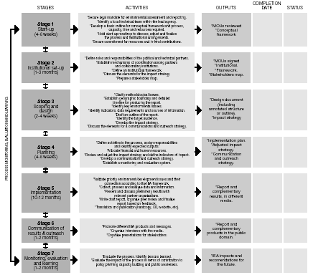

4. Planning a Self-Assessment
Having been equipped with all you need to develop your monitoring and evaluation plan, in Section 4 you will design a self-assessment matrix, your key tool for monitoring and evaluating the IEA process.
Internally-conducted monitoring and evaluation (i.e., self-assessment) as recommended in Section 2.2 requires planning. The International Development Research Centre (Lusthaus and others 1999) recommended a number of important aspects for planning your self-assessment, such as:
- issues for self-assessment;
- measures that will help you answer questions you have about various organizational and performance issues;
- data sources to answer these questions;
- methods of data collection best suited to your questions, realities and constraints; and
- priorities and frequency for checking progress.

Below are three recommended steps for self-assessment that you could follow.

Step 1 Identify major issues and monitoring questions, and develop specific measures.
Step 2 Identify sources of data and data collection methods.
Step 3 Set priorities and frequency of monitoring.

4.1 Step 1. Identify Major Issues and Monitoring Questions, and Develop Specific Measures
The first step in a self-assessment is to identify major issues that should be monitored and evaluated, and the key questions associated with these issues. Based on the framework introduced in Section 3, key issues and questions to be addressed include the following:
Outcomes
- Your Change Statement – Have the desired improvements in policies and policy processes that you identified in your impact strategy been realized? What other improvements in policies and policy processes have you observed during and following your national IEA process? (see section 3.3.1 for guidance)
- Effective Relationship Management – What changes in the thinking and actions of policy makers and decision makers (and other important relationships) have you observed? (see Table 2 for guidance)
Activities and Outputs
- Effective Knowledge Management – Is the right knowledge being generated, and is that knowledge salient, credible and legitimate? (see Table 5 for guidance)
- Effective Opportunity Management – Are opportunities being leveraged for effectively communicating that knowledge to those persons in a position to influence change? (see Table 4 for guidance)
- Timely completion of activities and outputs – Are the key activities and outputs necessary to complete your national IEA being completed on time and at the desired level of quality? (see Figure 6 for guidance)
Successful management of the national IEA process will require juggling these major issues effectively during each stage of the process.
A self-assessment matrix is a useful planning tool for internally conducted monitoring and evaluation (Lusthaus and others 1999). Tables 5 and 6 suggest ways to organize your self-assessment matrix, based on the above framework.

Table 5: Outcome-based Measures: Possible Organization of Your Self-Assessment Matrix
Key Issues/Questions | Specific Measures and Target (See Tables 2, 3 and 4 for guidance) | Data Source | Data Collection Method
Your Change Statement
Have the desired improvements in policies and policy processes that you identified in your impact strategy been realized?

What other improvements in policies and policy processes have you observed during and following your national IEA process?
Effective Relationship
Management
What changes in the thinking and actions of policy-makers and decision-makers (and other important relationships) have you observed?

Table 6: Activity and Output-based Measures: Possible Organization of Your Self-Assessment Matrix
Stage of the  National GEO  Process | Key Issues/Questions | Specific Measures  and Targets | Data Source | Data Collection  Method
Stage 1  Inception | Timely completion of activities and outputs  Effective Knowledge and Opportunity Management | See Figure 6 for guidance  See Table 3 and 4 for guidance
Stage 2  Institutional Setup | Timely completion of  activities and outputs  Effective Knowledge and Opportunity Management
Stage 3  Scoping and Design | Timely completion of  activities and outputs  Effective Knowledge and Opportunity Management
Stage 4  Planning | Timely completion of activities and outputs  Effective Knowledge and Opportunity Management
Stage 5  Implementation  of IEA | Timely completion of activities and outputs  Effective Knowledge and Opportunity Management
Stage 6  Communication  and Outreach | Timely completion of  activities and outputs  Effective Knowledge and Opportunity Management
Stage 7  Evaluation | Timely completion of  activities and outputs  Effective Knowledge and Opportunity Management

4.2 Step 2. Identify Sources of Data and Data Collection
Methods With a list of specific measures developed, it is now possible to identify sources of data and data collection methods for each measure. The data will come from a variety of sources. Accessing these data sources will demand a variety of data collection methods. Table 7 and 8 provide an overview of data collection methods for self-assessments (Lusthaus and others 1999).

Table 7: Overview of Typical Data Collection Methods
Questionnaire survey
It is distributed—or made accessible if online—to a predetermined selection of individuals.
Individuals complete and return the questionnaire or submit online.

Face-to-face interview
Interviewer asks questions, usually following a guide or protocol.
Interviewer records answers.

Telephone interview
Interviewer asks questions, usually following a guide or protocol.
Interviewer records responses.

Group techniques (interview, facilitated workshop, focus group)
This involves group discussion of predetermined issue or topic in person or through teleconferencing.
Group members share certain common characteristics.
Facilitator or moderator leads the group.
Assistant moderator usually records responses.
Document review
Researchers review documents, and identify relevant information.
They keep track of the information retrieved from documents.

Source: Lusthaus and others 1999

Collecting data for measures of relationship management requires that changes in behavior be identified and mapped as these incremental changes will lead towards the decisions or changes you are seeking. As noted in Module 3, this can be a time intensive process, so it is important to identify some key measures, and set up simple ways to monitor your strategy against those measures.
For example, you could take your list of key actors and set up a small contacts database with a journaling function that will allow you to record your interactions with them (see example screen below). This can be as simple as just indicating the date and type of contact.
- From you: Dates you sent information about the process, invitations to presentations, etc.
- From them: dates they requested information dates they accepted invitations.

You should keep a record of all your media inquiries. You can ask your government department whether they do media tracking (reviewing stories in the press about government initiatives; or more broadly, tracking issues of concern to the government). If they do, ask whether they would send you notices of stories in the press about your assessment, or about issues relevant to your assessment.
Selecting the most appropriate data collection method is mostly an intuitive process, depending on where the data are most likely to be found. Some guidance in this selection is provided in the table below.

Table 8: Guidance in the Use of Common Data Collection Methods for Self-Assessments
Use a surface mail or a faxed questionnaire survey when:
• The target population is large (for example, greater than 200).
• You require a large amount of categorical data.
• You want or require quantitative data and statistical analyses.
• You want to examine the responses of designated subgroups, such as male and female.
• The target population is geographically dispersed.
• You want to clarify your team’s objectives by involving team members in a questionnaire development exercise.
• You have access to people who can process and analyze this type of data accurately.

Use an e-mail or web page questionnaire when all of the above conditions are met and:
• You have the appropriate software and knowledge of this method.
• Your respondents have the technological capabilities to receive, read and return the questionnaire.
• Time is of the essence.
• You want to provide the option of typing long answers to questions.
• You want to reduce production and dissemination costs.

Use face-to-face interviews when:
• You need to incorporate the views of key people (key informant interview).
• The target population is small (for example, less than 50).
• Your information needs call for depth rather than breadth.
• You have reason to believe that people will not return a questionnaire.

Use telephone interviews when:
• The target population is geographically dispersed.
• Telephone interviews are feasible.

Use a teleconference interview when:
• The target population is geographically dispersed.
• Teleconferencing equipment is in place.

Use group techniques when:
• You need rich description to understand client needs.
• You believe that group synergy is necessary to uncover underlying feelings.
• You have access to a skilled facilitator and data recorder.
• You want to learn what the stakeholders want through the power of group observation (one-way mirror or video).

Use document reviews when:
• The relevant documents exist and are accessible.
• You need a historical perspective on the issue.
• You are not familiar with the organization’s history.
• You need hard data on selected elements of the organization.

Source: Lusthaus and others 1999

4.3 Step 3. Set Priorities and Frequency of Monitoring and
Evaluation Priority setting is a key consideration in finalizing a self-assessment matrix. Given resource and time constraints that are inherent in most national IEA processes, it will not be possible to monitor and evaluate everything that is considered relevant. Therefore, indicators that are identified for monitoring should be prioritized so that as resource constraints change, you can be assured that critical indicators will be monitored.
In addition to identifying monitoring priorities, establishing the frequency of monitoring for each indicator, and the person responsible for that stage will help to clarify the level of effort required. Process indicators typically will need to be monitored throughout the national IEA cycle on a frequency necessary for effective project management. Indicators for monitoring progress toward the impact strategy, while requiring less regular and frequent monitoring, require monitoring for several years after the national IEA report and other outputs have been disseminated. This is because it often takes many years for new information to influence policies in ways that are visible and attributable.
Exercise 5: Preparation of a Self-Assessment Matrix
The purpose of this exercise is to gain experience in identifying major issues and questions, and developing specific measures relating to both outcomes and activities/outputs.
In plenary, complete Table 5 relating to outcomes by identifying specific measures for the key issues and questions outlined in the table. Also in plenary, discuss and establish targets for each measure and identify data sources and data collection methods. (Time: ~ 40 minutes.)
In plenary, begin work on completing Table 6 relating to activities and outputs by reviewing the stages of your IEA process (drawing on exercises completed in Module 2). Assign a group to each stage. Each group is tasked with identifying specific measures for their stage which deal with timely completion of activities/outputs as well as effective knowledge and opportunity management (using Tables 2 through 4 and Figure 6 as guidance if necessary). (Time: ~ 45 minutes.)
Meet again in plenary to share the results for your stage with the group. As a group, prioritize the measures you developed in Tables 5 and 6. How many of these measures do you think your IEA team will have capacity to monitor and evaluate? (Time: ~ 15 minutes.)
The collection of self-assessment matrices for each stage will provide a good start for the actual matrix needed for your national IEA process.
Total time: ~ 90 minutes.

5. Improvement Opportunities
In this section you will learn how you can harness monitoring and evaluation in a learning process to improve the effectiveness of your national IEA process.
Thinking of an IEA as a capacity-building process helps increase its impact. The more monitoring and evaluation is treated as an organizational learning opportunity (versus a value judgment), the more effectively the IEA supports improvement in policy making and eventually human wellbeing.
The following evaluation steps show how a conscious learning approach can improve the IEA process:
- Formulate your change statement (Module 3).
- Identify measures for your change statement and other supporting measures for key outcomes and activities/outputs (your self-assessment matrices, Tables 5 and 6).
- Examine performance against making the desired changes and summarize results.
- Formulate lessons learned and recommendations.
- Integrate (feed back) recommendations to improve the next planning cycle.
One of the challenges is that learning is often not part of the daily vocabulary and thinking of managers and policy-makers, even when concepts like knowledge society and knowledge economy are quoted as desirable. Often, you will have to counter an attitude such as: “As a manager, a policymaker, I am paid to know, not to learn.” Learning is hard to sell unless it is coupled with professional, social and/or political rewards. High-level, multi-sectoral networking opportunities and political visibility constitute such rewards.
5.1 What do We Call Learning?
For the purpose of this module, we define learning as a process that brings about behaviour change or changes in the ability to act differently, based on emotional or cognitive changes taking place during information collection and processing.
This definition underscores three important points:
- learning is more than knowledge creation;
- learning is demonstrated by behaviour change; and
- information processing, in addition to information collection, is of paramount importance.
In preparing for promoting a learning culture throughout the IEA process, it is important to be aware of some of the characteristics of learning.
Both individuals and organizations learn in cycles characterized by well-defined phases. Typically, there are four phases in an individual learning process (Figure 7):
1. Linking the new experience to existing knowledge (connect).
2. Using the new experience to seek new information (take-up).
3. Applying the new information in an existing context (practice).
4. Using and reviewing the new information in a new context (use and review).
Evaluation and monitoring are learning opportunities during which we compare the knowledge and skills we have had with, the new knowledge and skills we gained, and we use lessons learned to improve our next decisions (action).

Figure 7: Learning Cycle

You can apply the learning cycle concept to enhance learning throughout the IEA process. In Exercise 6 you are going to experience how conscious learning can improve a specific stage of the national IEA process.
Exercise 6: Learning
The purpose of this exercise is to have a first-hand experience of how learning can enhance the IEA process.
Write what comes to mind based on the following four questions:
1. What did you hear during the IEA training course (e.g., Stage 1) that you had already known? (i.e. Connect new experience to existing knowledge.)
2. What new information and insight did you gain? (i.e., take ake up new knowledge)
3. How are you going to use this new insight? (i.e., practicing new knowledge in the current framework of operation)
4. How else and when could you use this new information? How could you improve policy making with this new insight? (i.e., review opportunities of using new knowledge in a new framework of operation.) (Time: 5 minutes.)
Discuss your findings with your neighbors. (Time: 5 minutes.)
In plenary, discuss what insights you have gained from this exercise? How did the group discussion help you to recognize improvement opportunities in the IEA process, and have better impact, such as changes in policy making? (15 minutes.)
In this exercise you combined individual and organizational learning. The same process of promoting organizational learning could be used during the IEA process.
Total time: 25 minutes.
Source: (Nonaka and Takeuchi 1990)
5.2 How Can We Recognize Learning Opportunities?
Learning opportunities arise when there is a possibility or a pressing need to act in a new way.
These opportunities naturally present themselves at the end of each stage of your IEA and at the end of the whole IEA cycle. You also can cultivate learning if you encourage participants to exchange and collectively process new information at any time during the IEA process. This is how discussion lists can work effectively.
Exchange of information and discussions (processing) are prerequisites for learning opportunities.
Yet, further conditions apply to fully realize them, including:
- motivation, which often is the urgency to solve a problem, or act with the support of new knowledge;
- trust to discuss values, assumptions and ideas without repercussions;
- mandate and opportunity to apply the new knowledge; and
- shared understanding of the importance of learning (not only what to learn but also how to learn) (Preskill and Torres 1996)
Each stage can be characterized by one or two of these learning conditions. Keeping these conditions in mind, you can enhance learning by using relevant exercises
5.3 How Can We Use Learning Opportunities?
In this final section, you are going to design a monitoring meeting that helps you and other participants monitor progress and cultivate learning.
As discussed earlier, learning opportunities naturally present themselves at the beginning and end of each IEA stage and each IEA cycle. These are the times when you need to reflect and articulate lessons learned to improve the next course of action.
Given the limited time available, we suggest that your core IEA team organize regular but brief, mid-stage and/or stage-end monitoring and evaluation meetings to serve two purposes:
1. Monitor progress toward and capture lessons learned to improve the next IEA stage and the next IEA cycle.
2. Cultivate a learning, improvement-oriented approach throughout the whole IEA process.
The two types of meetings—monitoring and evaluation—can be organized using the same principles, with due attention to their complementary differences (Table 1).
Based on the previous sections of Module 8, design a meeting that serves both monitoring and learning purposes (Exercise 7).
Considering the importance and the number of issues to cover, here are some practical considerations for organizing these meetings:
1. Allow sufficient time (3–6 hours) for these meetings; the first part can be dedicated to monitoring issues, and the second to consolidating learning, and improving the next stage(s).
For monitoring progress, you might want to arrange these meetings using a focus group discussion format which gives the meetings structure and flexibility. Design your focus group questions to cover three aspects: monitoring progress, capturing lessons learned, and articulating suggestions and commitments for improvement. Each discussion could be followed by discussing and filling out the relevant stage of the self-assessment matrix.
End the meeting by summarizing the progress and recommendations for improvement of the next stage and/or the next reporting cycle with special reference to desired impacts. Make the monitoring meeting notes available to all participants, especially for the user groups identified earlier in this module (Section 2.2).
2. Make sure to invite core group members, key stakeholders and targeted policy-makers.
3. A semi-formal or informal setting, as appropriate, will be most conducive to learning.
4. Create continuity by revisiting the previous monitoring meeting’s notes.
5. Be careful to manage gender balance and representation of underprivileged groups.
Gender balance and involvement of non-conventional groups can challenge the process at the beginning. However, it also contributes to equity and innovation. Women and other stakeholders (e.g., youth), who are not commonly invited to such processes, often have unique information and indigenous knowledge that can either challenge or confirm the information gained from conventional groups. Such non-conventional knowledge has high potential for offering innovative ideas for problem solving, and for providing breakthrough solutions. The diversity these representatives create in the monitoring group provides additional motivation and excitement for learning, and demand for improvement. For these reasons, seek opportunities to involve both targeted policymakers and stakeholders in the monitoring meeting who possess or have access to non-conventional and indigenous knowledge.
A learning approach to the national IEA process provides valuable opportunities to advance informed—evidence based—policy making with scientifically credible, and politically legitimate environmental assessments. Furthermore, it encourages willingness to learn and to act.
Exercise 7: Design a monitoring meeting
The purpose of this exercise is to design a monitoring meeting that supports learning to improve the national IEA process.
In groups of four or five, design a full-day monitoring meeting for any stage of the process using the guidance provided above. (Time: 15 minutes.)
One group presents their monitoring meeting design and in plenary, discuss the important elements of monitoring meetings. (Time: 10 minutes.)
Total time: 25 minutes.

References
Ballard, D. (2005). Using Learning Processes to Promote Change for Sustainable Development, Action Research, Special Issue on Change for Sustainable Development, Volume 3, Issue 2, June 2005.
Carden, F., Earl, S. and Smutylo, T. (2001). “Outcome Mapping. Building Learning and Reflection Into Development Programs.” International Development Research Centre, Ottawa. http://web.idrc.ca/en/ev-9330-201-1-DO_TOPIC.html (cited March 2006).
Alexander E. Farrell, Jill Jäger, Stacy D. VanDeveer (2006). Introduction: Understanding Design Choices, in Farrell, Alexander E., and Jill Jäger, eds. 2006. Assessments of Regional and Global Environmental Risks: Designing Processes for the Effective Use of Science in Decisionmaking. Washington, D.C.: Resources for the Future Press.
Fetterman, D.M., Kaftarian, S.J. and Wandersman, A. (ed) (1996). Empowerment Evaluation. Knowledge and Tools for Self-Assessment and Accountability. Sage Publications, Thousand Oaks.
Gardner, H. (1983). Frames of Mind: The Theory of Multiple Intelligences. Basic Books, New York.
OECD (2002) “Glossary of Key Terms of Evaluation and Results-based Management. OECD Development Assistance Committee. http://www.oecd.org/dataoecd/29/21/2754804.pdf (cited 26 July 2006).
Hall, S. (2005). Indicators of Sustainable Development in the UK. Conference of commonwealth statisticians. Seminar on measurement of sustainable development.
Herodek, A., Lacko, L., Virag, A. and Misley, K. (ed.) (1988). Lake Balaton: Research and Management, ILEC, UNEP, Ministry of Environment and Water Management, Hungary.
Lusthaus, C., Adrien, M. and Carden, F. (1999). “Enhancing Organizational Performance: A Toolbox for Self-Assessment.” International Development Research Centre, Ottawa. http://www.idrc.ca/en/ev-9370-201-1-DO_TOPIC.html (cited July 2006).
Millennium Ecosystem Assessment (2005). “Living Beyond Our Means: Natural Assets and Human Well-being.” http://www.millenniumassessment.org//en/Products.BoardStatement.aspx (cited 15 March 2006).
McCarthy, B. (1996). About Learning. Excel Inc., Barrington, Illinois, USA.
Meadows, D. and Seif, A. (ed) (1995). Creating High Performance Teams for Sustainable Development: 58 Initiatives. University of New Hampshire, Durham.
Meadows, D.H., Randers, J. and Meadows, D.L. (2004). Limits to Growth: The 30-Year Update. Chelsea Green Publishing, White River Junction.
Nonaka, I. and Takeuchi, H. (1995). The Knowledge-Creating Company: How Japanese Companies Create the Dynamics of Innovation. Oxford University Press, Oxford.
Patton, M.Q. (1997). Utilization-Focused Evaluation: The New Century Text. Sage Publications, Thousand Oaks.
Preskill, H. and Torres, R.T. (1996). From evaluation to evaluative inquiry for organizational learning. Paper presented at the American Evaluation Association Conference.
United Nations Population Fund (2004). “Programme Manager’s Planning, Monitoring and Evaluation Toolkit.” http://www.unfpa.org/monitoring/toolkit/defining.pdf (cited 19 July 2006).
Senge, P.M. (1990). The Fifth Discipline. The Art and Practice of the Learning Organization. Currency Doubleday, New York.
Siebenhüner, B. (2006) Can Assessments Learn and If How? – A Study of the IPCC in Farrell, A. and Jäger, J. (eds.) (2005). Assessment of Regional and Global Environmental Risks: Designing Processes for the Effective Use of Science in Decision Making, Washington, D.C.: Resources for the Future Press, pp/ 166–186.
Silver, F.H., Strong, R. and Perini, M. (2000). So Each May Learn. Integrating Learning Styles and Multiple Intelligences. Association for Supervision and Curriculum Development.
Steffen,W., Sanderson, A., Jäger, J., Tyson, P.D., Moore III, B., Matson, P.A., Richardson, K., Oldfield, F., Schellnhuber, H. J., Turner II, B.L. and Wasson, R.J. (2004). Global Change and the Earth System: A Planet Under Pressure, Springer-Verlag, Berlin.

